Music Lesson Plan topic - Water

Lesson 1 of 6 Focus: Year 3/4
Key Learning Objective:
- To explore the origin of sea shanties.
Other Learning Objective:
- To feel the pulse and clap rhythms at various tempi.
Inter-related music dimensions covered: Duration (rhythm), tempo.
Starter activity:
Watch www.youtube.com/watch?v=qGyPuey-1Jw&feature=related&safe=active (‘What Shall We Do With the Drunken sailor?’) and vimeo.com/62147900 ‘Don’t Forget Your Old Shipmate.’ Ask the children “what similarities between the two songs can you spot?” Explain that they are both examples of sea shanties.

Share the PowerPoint (in resources) to explain both the origin and purpose of sea shanties.

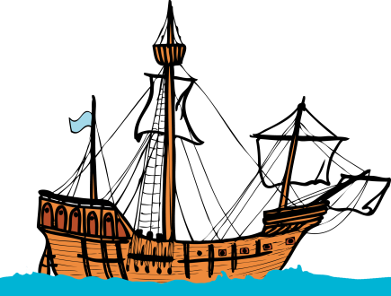
Main activity:
Learn ‘Three Pirates’ from the World Voice Songbook schoolsonline.britishcouncil.org/classroom-resources/world-voice/three-pirates (lyrics, videos and audio tracks can be found here).

Move into a circle, children to sit with their left palm facing up, right palm facing down so that they can tap on the palm of the child to their right and receive a tap from the child on their left. Explain that we are going to tap the “pulse” of a familiar song (e.g. ‘1, 2, 3, 4, 5 once I caught a fish alive’) as we sing. Children sing the song, tapping the pulse together.

Play the ‘Three Pirates’ and tap the ‘pulse’ in a circle. If time, move onto singing without the backing track. The children should continue to tap the pulse whilst they sing.

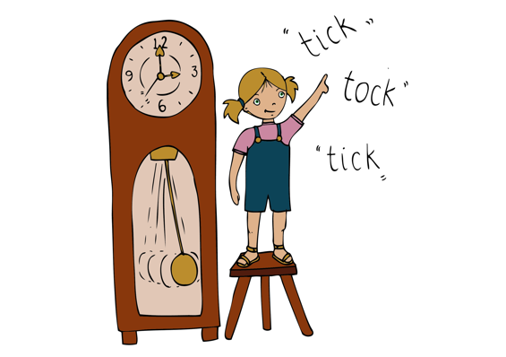
Plenary:
Revise the meanings of ‘pulse’ (a regular beat which you feel but do not hear) and ‘rhythm’ (a pattern made of beats of different lengths. On a whiteboard write out the first verse of Drunken sailor. Say the words with the class whilst clapping a pulse. Can they suggest which words fall on the beat. Highlight where the words are emphasised. This is the pulse, whereas the words indicate the rhythm.
What shall we do with the drunken sailor (4 beats in a line – the pulse)
Early in the mor-ning.
Ask the class to stand in two lines facing each other. One side walk on the spot and in time to the pulse whilst those facing them clap the rhythm as they sing/say the words. Then swap.
Keywords / vocabulary: Shanty, pulse, duration, rhythm.
Extension opportunities: Repeat the plenary activity changing the tempo (fast / slow). The children should demonstrate that they can feel the pulse and clap the rhythm of the words at the different tempi. Children to research sea shanties and famous Bristol pirates.
Self-assessment opportunities:
- I can keep the pulse whilst singing a sea shanty.
- I can tap the rhythm of the words.
- I can demonstrate an understanding of the difference between pulse and rhythm.
Resources: Introduction to Sea Shanties PowerPoint, recording and music of Drunken Sailor.
Opportunities for sharing work e.g. by recording, notation: Learn the song the ‘Three Pirates’ and teach it to the whole school in assembly.

Music Assessment: Year 3/4 Water Lesson 1
You only need to note the names of children who are working towards or well above the criteria for the lesson. It will be assumed that the majority of the class will achieve the objectives and you don’t need to record this. Use the space below for any specific notes on achievement or evaluation of class progress.

Names of any children who do not meet the learning objectives for this lesson | ‘I can’ assessment criteria | Names of any children who exceed the learning objectives for this lesson.
I can keep the pulse whilst singing a sea shanty.

I can tap the rhythm of the words

I can demonstrate an understanding of the difference between pulse and rhythm

Notes:

