Music Lesson Plan topic – Pitch

Lesson 2 of 6 Focus: Year 3/4
Key Learning Objectives:
- To continue to develop an understanding of pitch through kinaesthetic learning.
- To understand that the pitch of an instrument is often determined by the size of the instrument.
- To explore a partner song and sing the songs together in ensemble.
Inter-related music dimensions covered: Pitch, duration (pulse/rhythm).
Vocal Warm-Up: Select a few vocal warm-ups from the Vocal Warm-up Bank.

Starter activity:
Select an activity from the Pitch Starter Bank. As tennis balls are used in the main focus of this lesson, you might like to select ‘Throw it high, bounce it low’, which also uses tennis balls.

Note: To develop kinaesthetic learning and further an understanding of pitch and pulse, this lesson uses balls. A larger space, such as the school hall, would work particularly well. However, the classroom would be a suitable alternative. Any bouncy ball would work well here, tennis balls might be better if space is limited. However, basket balls would be a good alternative for children who may find this kind of gross motor, hand-eye co-ordination activity challenging.
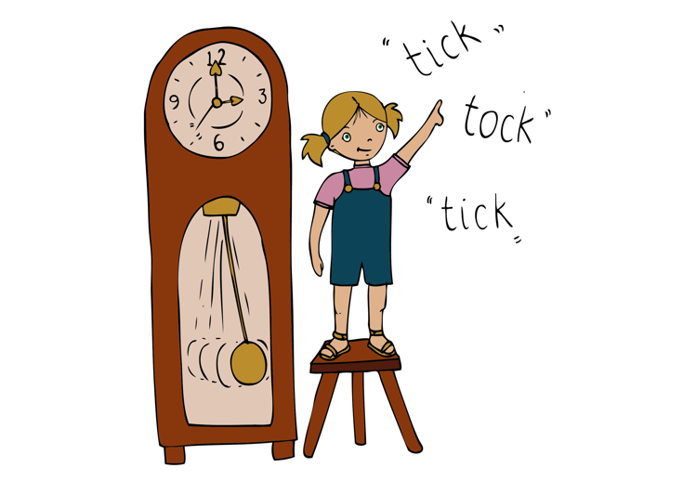

Main focus:
- Remind the children of the song ‘Land of the Silver Birch’ by listening to it again. To encourage active listening and understanding of pulse, place the children in partners and pairs throw or roll the ball back and forth on the strong beat of the bar. This song has a 2/2 time signature, which means the count is 1, 2…1, 2 as the music plays. *pass, 2, pass, 2*

*pass * *pass* *pass* *pass*
Land of the silver birch, Home of the beaver.

*pass* *pass* *pass* *pass*
Where still the mighty moose Wanders at will.

- In this piece, voice 2 sings the partner song ‘My Paddle’, at the same time as ‘Land of the Silver Birch’. ‘My Paddle’ is another traditional Canadian song that was sung to keep canoe paddlers in time with one another. Listen to ‘My Paddle’, paddling along in time with the pulse.
- Highlight the repeated phrase ‘dip, dip and swing’. Sing this together. Can the children hear which word is sung on the lowest note of the phrase? (and) . All sing ‘dip, dip and swing’, each time it appears, bouncing the ball on the ground to highlight the lowest note in the phrase. Notice how the ball falls to the ground on the lowest note, mirroring the fall in pitch.

*bounce*
Dip, dip and swing.
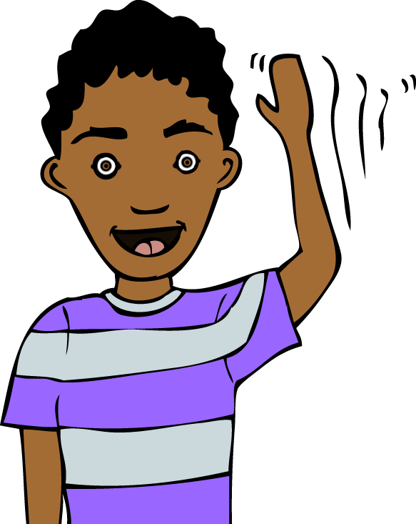
- The largest interval (leap) in this song can be heard between the two notes sung on ‘Sil-ver’. (A and D). The highest note here (D) is also the highest note sung in both ‘My Paddle’ and ‘Land of the Silver Birch’. The children should place their hands on their shoulders and then raise them high into the air to mirror this leap in pitch each time it appears. Hands raised high in the air (to tickle the sky!) will remind us that this is the highest note in this piece.

*shoulders* *air*
Sil- ver

- Listen to both songs performed together to hear how the two partner songs fit together. The children should join in singing ‘My Paddle’, raising their hands in the air each time they hear the leap on ‘Silver’. On the word ‘paddle’ they should hold an imaginary paddle with two hands and dip it into the water on the word to mirror the change in pitch each time they hear the words Dip, dip and swing.
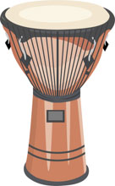
- Show the children two drums (the largest drum that you can find, plus the smallest drum that you can find). Ask the children which they think will sound lower? Why? Play both drums. Were pupils correct? (The bigger drum has more skin/surface area to vibrate, and therefore it will sound the lowest. This rule applies to all instruments: the larger the instrument, the lower the possible pitch).
- Invite a ‘leader’ to the front to play the two drums to keep the rest of the ‘paddlers’ in time with the pulse. It is important to choose a child who can maintain a steady pulse on their own. Alternatively, the teacher could play the drums here. Sing My Paddle, with the ‘leader’ playing both drums to the same rhythm as the claps and finger snaps from the previous lesson. *low, high high….low, high high*

Plenary:
Listen to the song ‘Bristol Pitche’s. It mentions lots of Bristol landmarks. How many landmarks can the children identify that they have visited or that they recognise? Can the children hear what is happening to the pitch throughout the song? (It is gradually getting higher, step by step). Listen again, this time singing the sustained notes (C…D…E…F…etc) and raising hands (pitch tracing) to mirror the rising pitch throughout the song. How do the pitches move (by step up a scale).

Opportunities for mastery: Consider pitches of different string instruments within an orchestra. (Double bass, cello, viola, violin). Can the children name each of the instruments in the string family? Can pupils order these from lowest to highest, based on their pitch? Remember that the largest instrument has the lowest pitch. This is because larger instruments have more space for the sound to vibrate.
Look at the real instruments, if you have them at school.
See https://www.mydso.com/dso-kids/learn-and-listen/instruments/violin
Answer (from lowest pitch to highest): Double bass, cello, viola, violin.

Keywords / vocabulary: Pitch (high/low, highest/lowest) instrument, duration (pulse), interval (leap/step), scale, time signature.
Self-assessment opportunities:
- I can demonstrate my understanding of pitch by moving my body to mirror what I hear.
- I can learn that pitch is linked to instrument size.
- I can listen carefully and maintain a musical line in an ensemble.
- Mastery self-assessment opportunity: I can use my understanding of pitch to place stringed instruments in order of pitch, from lowest to highest.
Resources:
Backing and performance tracks ‘Land of the Silver Birch’ and ‘My Paddle’.
30 bouncy balls (tennis/basketballs etc).
One large drum (the largest you can find).
One smaller drum (the smallest you can find).
Performance track ‘Bristol Pitches’.
Vocal Warm Up bank.
Mastery opportunity:
Stringed instruments powerpoint or real instruments (double bass, cello, viola, violin).

Opportunities for sharing work e.g. by recording, notation: Create a large paddle boat performance and record it. The children should sit in two long lines with a gap in the middle. The ‘leader’ stands at the front with the two drums. Sing ‘My Paddle’, with the ‘leader’ playing the two drums and the rest of the ‘paddlers’ paddling in time with the pulse. The left line of children paddle to their left. The right line of children paddle to their right. This creates a large boat!

Music Assessment: Year 3/4 Pitch Lesson 2
You only need to note the names of children who are working towards or well above the criteria for the lesson. It will be assumed the majority of the class will achieve the objectives and you don’t need to record this. Use the space below for any specific notes on achievement or evaluation of class progress.

Names of any children who do not meet the learning objectives for this lesson | ‘I can’ assessment criteria | Names of any children who exceed the learning objectives for this lesson.
I can demonstrate my understanding of pitch by moving my body to mirror what I hear.

I can learn that pitch is linked to instrument size.

I can listen carefully and maintain a musical line in ensemble.

Mastery: I can use my understanding of pitch to place stringed instruments in order of pitch, from lowest to highest.
Notes:

