Music Lesson Plan topic – Pitch

Lesson 1 of 6 Focus: Year 3/4
Key Learning Objectives:
- To develop an understanding of pitch through kinaesthetic learning.
- To listen to and trace the pitch of a melody.
- To learn that the leaps in-between notes are called intervals.
Inter-related music dimensions covered: Pitch, duration (pulse/rhythm), dynamics, structure.
Vocal Warm-Up:
Select a few vocal warm-ups from the Vocal Warm-Up Bank. As this unit focusses in particular on using the voice, it is important to do a brief warm-up at the beginning of every lesson. This helps everybody to be energised and ready to sing! We recommend you try one from each ‘focus group’.
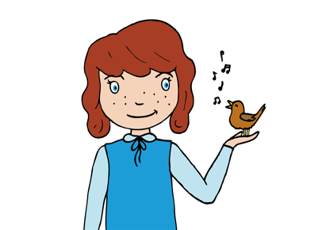
Starter activity:
Select the ‘aeroplane trail’ activity from the ‘Pitch Starter Bank’.

Main focus:
Listen to ‘Land of the Silver Birch’, a traditional Canadian song inspired by a poem by Pauline Johnson.
It describes the Canadian landscape. As you listen, invite the children to close their eyes. What pictures does the music paint in your mind? What can you see? (silver birch trees blowing in the wind, flowing rivers, birds soaring, a river lapping…)
Listen again. This time, note that the song begins with a 4 bar introduction. Count this together by whispering
- ‘hi-a-ya, hi-ya
hi-a-ya, hi-ya
hi-a-ya, hi-ya
Ah.’
Now join in with the claps and finger snaps that you can hear. ‘Clap, snap snap…’ It is important to listen carefully to keep a steady pulse. If the sound of the claps is drowning out the music, try tapping two fingers on the palm of your hand instead.
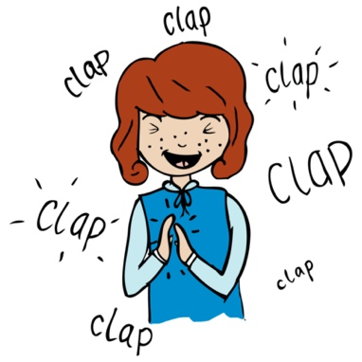
- Highlight that the chorus ‘Blue lake and rocky shore, I will return one more. Hi-a-ya, hi-ya…’ has the same pitch and lyrics each time it appears. Can the children raise a hand on the highest note during the ‘hi-a-ya, hi-ya’ passage? (ya). In partners, the children should join in with this phrase each time by clapping hands with their partner above their heads on the highest note (ya). To add dynamic interest, try singing this phrase as a crescendo (gradually getting louder) or a diminuendo (gradually getting quieter).
- Every verse of the song begins with a leap between the notes D and A. Listen to the first verse ‘Land of the Silver Birch, home of the beaver’. Can the children hear the change in pitch? One note is higher than the other. This leap from one note to another is called an interval. Some intervals between notes are larger than others. This interval (D/A) is bigger than the interval between the notes in ‘hi-a-ya, hi-ya’ (D/F). It is interesting to note that this D/A interval is the same as at the beginning of ‘Twinkle, twinkle little star’.
- Now sing the whole song through. Each time the children sing this interval/leap form D/A, ask them to touch your toes/head to mirror the interval/leap between the notes.
Toes Head Toes Head
Land of the Silver Birch Home of the beaver

Now ask the children to touch toes / knees in ‘hi-a-ya hi-ya’ (knees is on the last ‘ya’ in each line) (See Video file)
Toes Knees
‘hi-a-ya, hi- ya’

Plenary:
The melody and rhythm throughout the next two verses is almost identical. Divide the children into four groups to sing the entire song together. If the children are confident, try this using the backing track without voices. Alternatively, continue joining in with the performance track voices.
Group 1- Sing the melody
Group 2- Clap and finger snap throughout
Group 3- In partners, clap above heads each time they hear ‘hi-a-ya, hiy-a…’
Group 4- Touch toes and head each time they hear the leap at the beginning of each verse.
Record this!!! Rotate the groups to give everyone a chance to perform all the parts.
Opportunities for mastery: As a class try ‘tracing the pitch’ of some of the piece. Hold one hand, palm facing downwards out in front of you, level with your chest. Move your hand up for higher notes and down for lower notes. Can the children identify the highest note sung throughout the song? (D- sung on ‘blue’ in ‘blue lake and rocky shore.’)

Keywords / vocabulary: Pitch (high/low, highest/lowest), interval/leap, dynamics, (getting louder/softer crescendo/diminuendo), structure (verse/chorus), duration (pulse/rhythm), melody, lyrics.

Self-assessment opportunities:
- I can listen carefully and identify high and low pitched sounds.
- I can demonstrate my understanding of pitch by moving my body to mirror what I can hear.
- I can learn that a leap between notes is called an interval.
- I can understand that some intervals are bigger than others.
- Mastery self-assessment opportunity: I can understand that ‘tracing the pitch’ is using my hand to mirror a rise and fall in pitch.

Resources:
Tracks of: ‘Land of the Silver Birch’
Vocal Warm up Bank and Pitch Starter Bank.

Opportunities for sharing work e.g. by recording, notation: Record the whole class performance of ‘Land of the Silver Birch’ to share with another class. Try recording the class ‘pitch tracing’ the song in order to show this technique to another class.

Music Assessment: Year 3/4 Pitch Lesson 1
You only need to note the names of children who are working towards or well above the criteria for the lesson. It will be assumed the majority of the class will achieve the objectives and you don’t need to record this. Use the space below for any specific notes on achievement or evaluation of class progress.

Names of any children who do not meet the learning objectives for this lesson | ‘I can’ assessment criteria | Names of any children who exceed the learning objectives for this lesson.
- I can listen carefully and identify high and low pitched sounds.

- I can demonstrate my understanding of pitch by moving my body to mirror what I can hear.

- I can learn that a leap between notes is called an interval.

- I can understand that some intervals are bigger than others.

- Mastery self-assessment opportunity: I can understand that “tracing the pitch” is using my hand to mirror a rise and fall in pitch.

Notes:

