Music Lesson Plan topic – Rhythm (Junk Band)

Lesson 6 of 6 Focus: Year 3-4
Key Learning Objectives:
- To explore timbre, texture and rhythm using everyday items as instruments.
- To listen to and repeat a variety of rhythms using instruments.
- To play in an ensemble and develop ensemble and listening skills.
- To explore experimental music by composing rhythms.

Inter-related music dimensions covered: Duration (pulse, rhythm), timbre, dynamics, structure, texture.

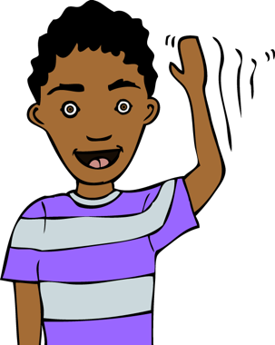
Starter activity:
Select an activity from Rhythm Starter Bank.

Main focus:
Remind children of Stomp by showing [www.youtube.com/watch?v=tZ7aYQtIldg] (1. 54 onwards).

Explain that today, the children will become Stomp musicians and will work in groups to compose their own piece of music.
- Show composers’ checklist to explain the different features that each composition must include.
- Show Ensemble Award checklist to explain the musicianship skills that you will be looking for and to use as a positive behaviour management strategy to ensure that rehearsal sound making is productive! Optional: teacher could show Ensemble Award certificate and explain that these will be handed out to groups that display the skills on the checklist.
- Split children into small groups.
Give groups time (15-20 minutes, although if you had more time available this activity could easily be extended to last up to 40 minutes) to work together to compose a short piece of Stomp inspired music.

- Move around the room to prompt children to work together, challenge themselves and make musical choices. Some helpful scaffolding questions may include:
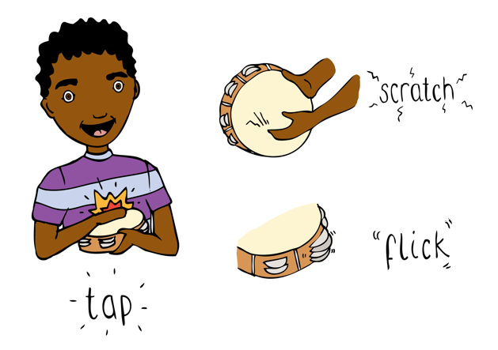
- How are you going to start / what about joining in one at a time with this sound?
- Have you included a piano/forte sound?
- Have you included a Bristol place rhythm?
- How will you all know when to stop making this sound and start another? Would a conductor help (Stomp doesn’t use one!)? Remember that you can’t talk to each other during the performance.
- Have you considered swapping instruments?
- Can you pass that sound around the group as part of your piece?
- What happens when you all play a different rhythm at the same time? Perhaps pairs of children could play different rhythms? This will create different textures.
Plenary:
Watch and listen to each group’s piece. Encourage peer assessment. Before performing again discuss what makes a “good audience”. Encourage audience to look for signs of good ensemble skills and items included from the composers’ checklist. After each performance, ask someone from the audience to say something positive that they spotted.
Optional: At this point, teacher could give out Ensemble Award Certificates to groups that have worked well as an ensemble both in rehearsal and performance.
Keywords / vocabulary: Timbre, duration (pulse, rhythm), instruments, ensemble, Stomp, dynamics, piano (soft), forte (loud), repeat, structure, texture.

Self-assessment opportunities:
- I can work with my ensemble to compose rhythms and structure these to form a piece of music
- I can show good ensemble skills including listening, eye contact, sharing ideas and being able to start and stop as a group.
- I can include items from the composers’ checklist in my composition.

Resources:
Rhythm Starter Bank.
Stomp video clip.
Stomp instruments (this can be anything that is not “technically” a musical instrument! Spoons, stationery from the classroom, brooms, brushes, kitchen utensils such as whisks, potato mashers, wooden spoons, bins, pots and pans etc).
iPad / digital camera / phone / tablet / easi-speak to record performances.
Composers’ checklist.
Ensemble Award checklist.
Ensemble Award certificates (optional).

Opportunities for sharing work e.g. by recording, notation: Record performances with an iPad to share with another class.

Music Assessment: Year 3 and 4 Rhythm Lesson 6
You only need to note the names of children who are working towards or well above the criteria for the lesson. It will be assumed the majority of the class will achieve the objectives and you don’t need to record this. Use the space below for any specific notes on achievement or evaluation of class progress.

Names of any children who do not meet the learning objectives for this lesson |  | Names of any children who exceed the learning objectives for this lesson.
- I can work with my ensemble to compose rhythms and structure these to form a piece of music

- I can show good ensemble skills including listening, eye contact, sharing ideas and being able to start and stop as a group.

- I can include items from the composers’ checklist in my composition.

Notes:

