Music Lesson Plan topic – Rhythm (Junk Band)

Lesson 5 of 6 Focus: Year 3/4
Key Learning Objectives:
- To explore timbre using everyday items as instruments.
- To listen to and repeat a variety of rhythms using instruments.

Inter-related music dimensions covered: Duration (pulse/rhythm), timbre, dynamics.

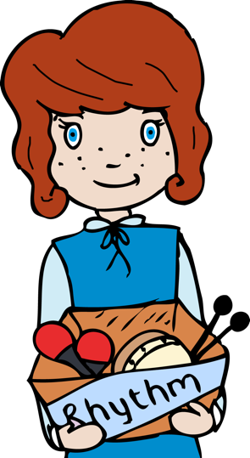
Starter activity:
Select an activity from Rhythm Starter Bank.

Main focus:
Watch Stomp videos (Stomp is a musical where musicians use everyday items as instruments).
www.youtube.com/watch?v=tZ7aYQtIldg (1.54 onwards)
www.youtube.com/watch?v=EULpbJQLzSg (2.27 onwards)
www.youtube.com/watch?v=5-0lrHhpvGM (6.16 onwards)

As they watch, ask the children to consider:
- What are the musicians using as their instruments? (brooms, cups, sinks, washing up brushes)
- How are the musicians ensuring that they play together as an ensemble? (eye contact, listening, the musicians have rehearsed)
- Can you spot any similarities between the three pieces? (unusual instruments, repeated rhythms, using instruments in creative ways)
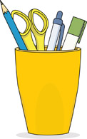
- Which piece is the odd one out? Why? (Many possible answers, as long as the children can justify their response. It is interesting to note here that the third piece is piano (soft) whereas the others are mostly forte (loud).

Split children into small groups.
- Give one “stomp style” instrument to each group. (Anything that makes a sound will work here! A list of suggestions can be found in the resources section of the plan).
- Play “pass the sound around.” One person in the group uses their instrument to make a sound (e.g. scraping it on the table) and passes it to the next person who makes a sound in a different way (tapping the handle). Continue around the circle to see how many different ways there are to make different sounds with this instrument. (Recap that every instrument has its own tone colour or “timbre”. For example a metal instrument sounds different from a wooden one and hitting the skin of a drum sounds different from blowing a recorder. A variety of “timbre” can be created by one instrument.).
- Teacher to hand out one instrument per child.
- Teacher to introduce some Bristol place name rhythms. Teacher plays a Bristol place rhythm (e.g. Bed-minster Down) with their instrument and the children copy using theirs. (Bed-minster Down)
- Play “don’t clap our school back.” Teacher to play a variety of Bristol place rhythms, which the children play back. However, when the teacher plays the name of your school (e.g. Hor-field Pri-ma-ry.) the children don’t play, but say back “Horfield Primary.” Play some rhythms softly (piano) and others loudly (forte) for the children to copy. (examples could include Ashley Down Withywood, Southmead Filton, Shirehampton Easton.) See video resource.

Plenary:
Sit in a circle, each holding one stomp instrument. Each child take it in turns to play their name using their instrument (Chris-to-pher) This can be made more challenging by each person playing the name of the person to their left, plus their own name (Lau-rel, Chris-to-pher; Chris-to-pher, Kir-sten; Kir-sten, Soph-ie). You could do this over a rhythm backing track.
Keywords / vocabulary: Timbre, duration (pulse, rhythm), instruments, ensemble, Stomp, dynamics, piano (soft), forte (loud).

Self-assessment opportunities:
- I can produce different timbres with an everyday object.
- I can listen carefully and repeat rhythms.
- I can spot the difference between rhythms.
- I can recognise and perform contrasting dynamics.

Resources:
Rhythm Starter bank, Stomp video clips, Stomp instruments (this can be anything that is not “technically” a musical instrument! Spoons, stationery from the classroom, brooms, brushes, kitchen utensils such as whisks, potato mashers, wooden spoons, bins, pots and pans etc)

Opportunities for sharing work e.g. recording: N/A

Music Assessment: Year 3 and 4 Rhythm Lesson 5
You only need to note the names of children who are working towards or well above the criteria for the lesson. It will be assumed the majority of the class will achieve the objectives and you don’t need to record this. Use the space below for any specific notes on achievement or evaluation of class progress.

Names of any children who do not meet the learning objectives for this lesson | ‘I can’ assessment criteria | Names of any children who exceed the learning objectives for this lesson.
- I can produce different timbres with an everyday object.

- I can listen carefully and repeat rhythms.

- I can spot the difference between rhythms.

- I can recognise and perform contrasting dynamics

Notes:

