Music Lesson Plan topic – Rhythm- (Junk Band)

Lesson 4 of 6 Focus: Year 3/4

Key Learning Objectives:
- To compose and play rhythms including rests.
- To understand how rests are notated.
- To begin to notate rhythms including rests.
Inter-related music dimensions covered: Duration (pulse, rhythm), dynamics, notation, timbre.

Starter activity:
Select an activity from the Rhythm Starter Bank.

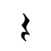
Main focus: Recap the symbol for a crotchet / ¼ note rest. Ask a child to recreate the below rhythm using cups. (As shown in photo 1 below and on Powerpoint resource).
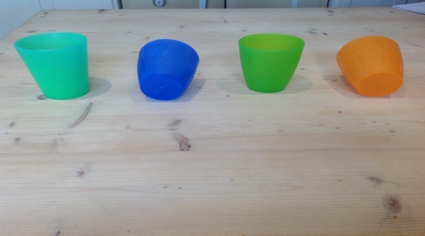
1

clap, *silence* clap, *silence*

- Teacher: tip different combinations of cups and ask class to play them to consolidate understanding from previous lesson.
- Split children into small groups and give each group 4 cups. (Note: you could give each group 8 cups instead to make the activity more challenging)
- Children to tip cups to create a 4 beat rhythm and rehearse clapping this rhythm together as an ensemble (a group of musicians playing together).
- Ask one child in each group to be the conductor to help the ensemble to clap together. The conductor should stand/sit close to the cups and move their hands steadily over each cup as their group plays. (This is a great role for a more confident musician)
- Optional extension activity: Some groups, or indeed the whole class, could add an upside down cup to their rhythm. (An example is shown in photo 2). They could assign a different body percussion sound to this cup (tapping knees, click, vocalised sound). Teacher to introduce vocabulary timbre (quality of sound/tone colour) e.g. the sound click is different to ‘clap’ the sound.
2
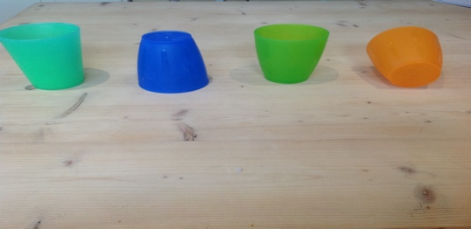

Clap, click, clap, *silence*

- Provide children with a 1x4 grid. Ask each group to notate their rhythm using crotchet/quarter note and crotchet/ quarter note rests. (Note: if the group has used the optional extension activity they will need to think of a way of differentiating this sound from the crotchets used to notate the clap. This could be achieved by colour coding the crotchets/quarter notes).
- Each group should now have 4 cups and a grid notating their rhythm. Groups can now move around the room to play each other’s cup rhythms by looking at the cups and notation grids. The teacher could remove the cups altogether to ensure that the children are reading the notation grids that each group has produced.

Plenary:
Groups return to sit by their original cup rhythm. Teacher to conduct whole class performance of cup rhythms. Use one of the rhythm backing tracks in 4 to accompany your rhythms. Try to only use hand signals, rather than speaking. You can use any hand signals that clearly communicate what you would like the children to do. If you are unsure, here are some suggestions:
- Both hands open, palm up, held towards one group to signal that they should begin to play their rhythm.
- Roll hands over one another to signal that this group should continue playing over and over again.
- Both hands open towards a second group to signal that they should begin.
- Roll hands to show that this group should continue.
- Keep bringing each group in until all the children are playing their rhythms together.
- Hold both hands palm down and sweep outwards to signal stop to one group at a time or to the whole class.
- If you are confident conducting in four then you could try this.

- Lift arms higher into the air to indicate different dynamics “play louder” (forte) and hold arms lower to indicate “play softly” (piano).
- You could also invite a child to be the conductor and use these actions to lead the whole class.

Keywords / vocabulary: Duration (pulse, rhythm), rests (beats of silence), crotchet, quarter note , crotchet/quarter note rest, composition, conductor, notation, forte - loud , piano - soft, timbre/tone colour.

Self-assessment opportunities:
- I can listen carefully to clap rhythms that include rests
- I can notate my compositions using crotchets/quarter note and crotchet/quarter note rests.
- I can perform other group’s compositions by reading their notation grids.
- I can perform with contrasting dynamics.

Resources: 4 cups per group of 6 (24 cups) plus some for teacher demonstrations, Year 3 Rhythm cards, 1 x 4 grid for each group, Rhythm Starter bank.
Extension activities: additional cups (24 more if each group is using 8 cups), 1 x 8 grids.

Opportunities for sharing work e.g. by recording, notation: Record plenary performance and conducting using ipad to share with another class in the school.

Music Assessment: Year 3 and 4 Rhythm Lesson 4
You only need to note the names of children who are working towards or well above the criteria for the lesson. It will be assumed the majority of the class will achieve the objectives and you don’t need to record this. Use the space below for any specific notes on achievement or evaluation of class progress.

Names of any children who do not meet the learning objectives for this lesson | ‘I can’ assessment criteria | Names of any children who exceed the learning objectives for this lesson.
- I can listen carefully to clap rhythms that include rests

- I can notate my compositions using crotchets/quarter note and crotchet/quarter note rests

- I can perform other group’s compositions by reading their notation grids

- I can perform with contrasting dynamics

Notes:

