Music Lesson Plan topic – Rhythm (Junk Band)

Lesson 3 of 6 Focus: Year 3/4
Key Learning Objectives:
- To understand that rhythm is a pattern made of notes of different lengths.
- To understand that rests are beats of silence.
- To play and compose rhythms that use rests.

Inter-related music dimensions covered: Duration (pulse, rhythm), silence.

Starter activity:
- Children sit in a circle. Teacher: lay out 4 cups (as shown in photo 1) Explain that there is music hidden inside these cups. They sound like this: clap, clap, clap, clap. (Clap your hands above each cup).
1

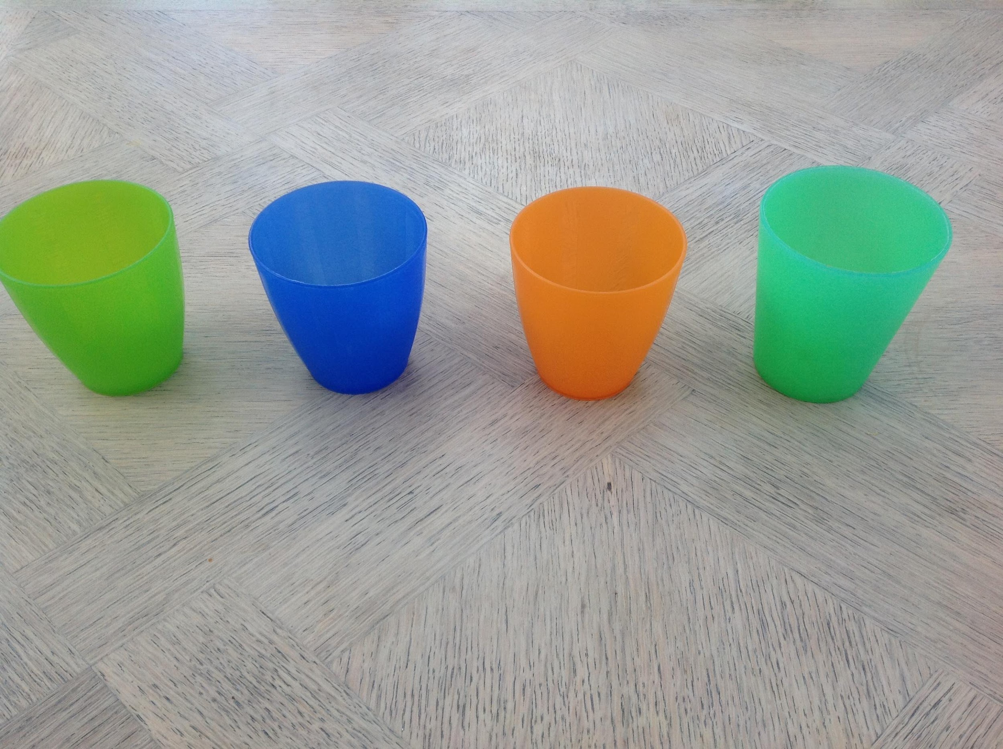
clap, clap, clap, clap

Ask: “How many cups are there?” (4) “How many times do we clap?” (4) There are 4 cups because there are 4 beats. All clap four times, looking at the cups.

- Teacher: tip one cup onto its side (as shown in photo 2) Ask: What do you think this means?” (Take a variety of suggestions. Many could be possible, but answer is “don’t clap.”) Ask again: “how many cups are there?” Still 4, as there are still 4 beats but one is a beat of silence. These cups sound like “clap, clap, *silence,* clap” All clap what these cups sound like. It is important to hold both hands open over your knees during the silent beat to make sure that the rest occupies one beat of silence.
2

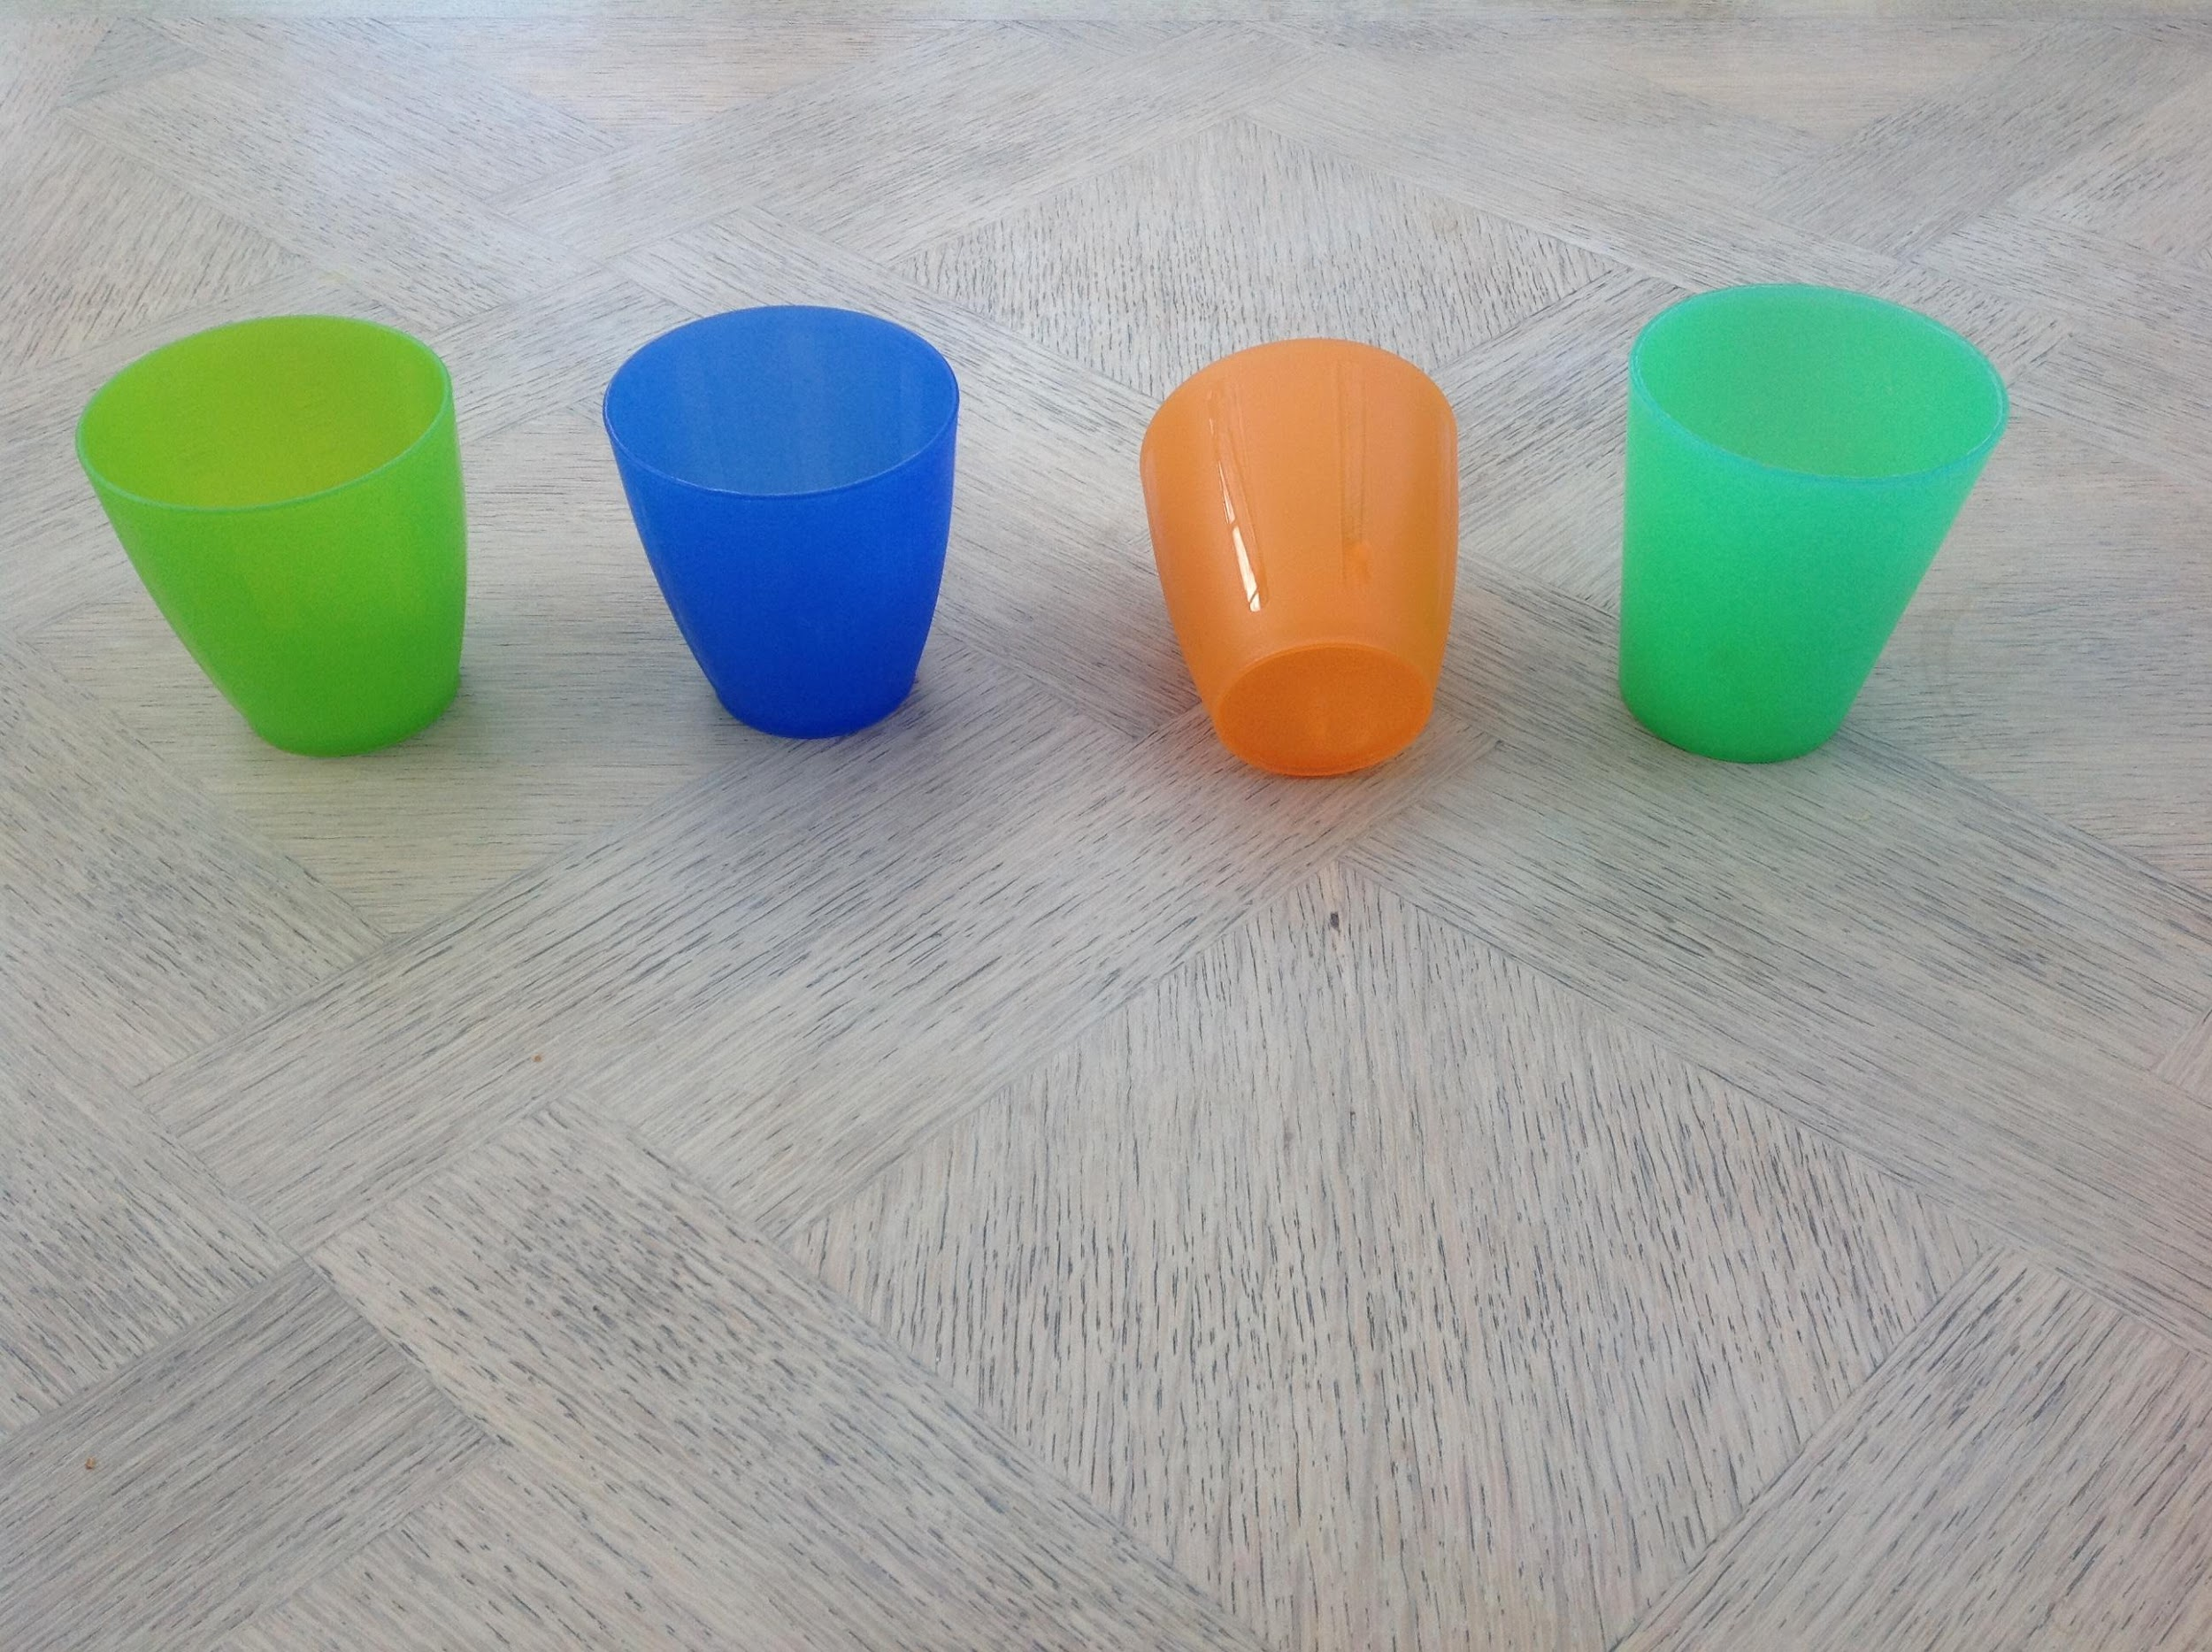
clap, clap, *silence* clap

clap, clap, *silence* clap

- Teacher tip over different cups and ask class to clap what the different combinations sound like. (An example is shown in photo 3).

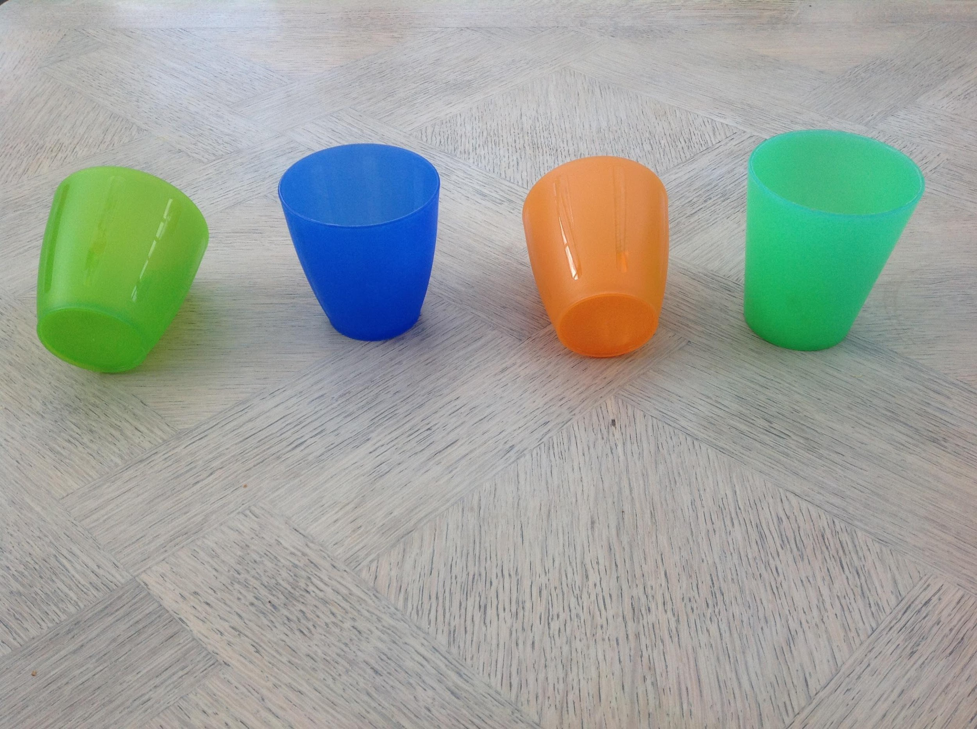
3

*silence* clap, *silence* clap

Main focus: Invite children to be composers (someone who writes music) and come to the front to tip up cups to create rhythms. This child can also take the role of a conductor to keep a regular pulse by moving their hands over the cups as the children clap the different combinations. Ensure that children hold their hands over their knees to observe an entire beat of silence during ‘the silence’.
Note: this lesson would also work well using 8 cups instead of 4 to make it more challenging.

Plenary: Sing B.I.N.G.O. from Singup – this song encourages children to internalise lyrics.

Keywords / vocabulary: Duration (pulse, rhythm), beats (4 beats), rests (beats of silence), conductor, composer.

Self-assessment opportunities:
- I can keep a regular pulse when playing rhythms that include rests.
- I can understand that a rest is a beat of silence.
- I can follow the conductor and listen carefully to echo/clap rhythms that I hear.

Resources: 4 plastic cups, Singup.

Opportunities for sharing work e.g. Children could be filmed / recorded playing their rhythms.

Music Assessment: Year 3 and 4 Rhythm Lesson 3
You only need to note the names of children who are working towards or well above the criteria for the lesson. It will be assumed the majority of the class will achieve the objectives and you don’t need to record this. Use the space below for any specific notes on achievement or evaluation of class progress.

Names of any children who do not meet the learning objectives for this lesson | ‘I can’ assessment criteria | Names of any children who exceed the learning objectives for this lesson.
- I can keep a regular pulse when playing rhythms that include rests.

- I can understand that a rest is a beat of silence.

- I can follow the conductor and listen carefully to echo/clap rhythms that I hear.

Notes:

