Music Lesson Plan topic – Rhythm (Junk Band)

Lesson 2 of 6 Focus: Year 3/4
Key Learning Objectives:
- To understand that the 1st beat of the bar is the ‘strong’ beat.
- To further consolidate understanding of duration (pulse) using kinaesthetic learning to internalise.

Inter-related music dimensions covered: Duration (pulse / rhythm).

Starter activity:
Select an activity from the Rhythm Starter Bank.

Note: This lesson uses balls to promote kinaesthetic learning and develop understanding of pulse. A larger space, such as the school hall would work particularly well. However, the classroom would be a suitable alternative. Any bouncy ball would work well here, tennis balls might be better if space is limited, however basket balls would be a good alternative for children who may find this kind of gross motor, hand-eye co-ordination activity challenging.
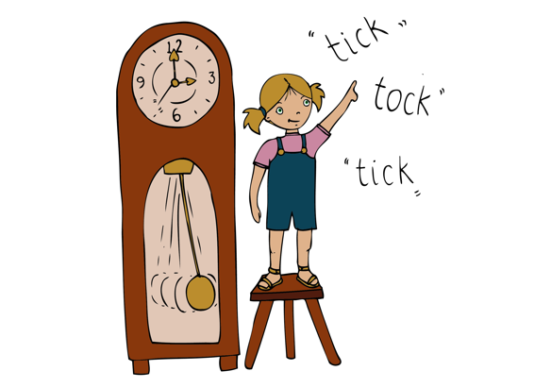
Main focus:
Recap definition of pulse from lesson one. Play a different 4/4 track from the bank and ask children to “tap the pulse” on their knees.
- Using a tennis balls in pairs, demonstrate rolling the ball to your partner on the 1st beat of the bar. Explain that the 1st beat is the ‘strong’ beat of the bar. (Roll, 2, 3, 4, Roll, 2, 3, 4)
- Give each child a ball. Children now bounce the ball on the first beat (bounce, 2, 3, 4, bounce, 2, 3, 4). Encourage children to count aloud “Bounce, 2, 3, 4” and then move into thinking voice.
- If you would like to make this more challenging, children could work in pairs, bounce passing the ball back and forth to one another (Bounce, 2, 3, 4, Bounce, 2, 3, 4)

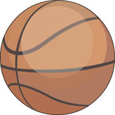
Show video of Stomp [vimeo.com/65794081] (Start watching at 00:51) musicians using basketballs to play rhythms. Ask for similarities and differences between what we have been doing and what happened in the video (some similarities: both using balls, bouncing and passing, using thinking voices. Differences: not all doing the same actions at the same time, basketballs/tennis balls, also including body percussion). Highlight that the musicians in the video are creating rhythms with the basketballs. Explain that a rhythm is a pattern made of notes of different lengths, rather than a regular beat (pulse).

Plenary:
Teach and sing ‘Bounce High, Bounce Low ‘ (Singing Games for Middle Years published by National Youth Choir for Scotland) using a ball to bounce around the circle.

Keywords / vocabulary: Duration (pulse / rhythm), strong beat, thinking voice
Self-assessment opportunities:
- I can understand that the pulse is a regular beat that I can feel but not always hear.
- I can march and tap the pulse by counting “1, 2, 3, 4” in my thinking voice.
- I can demonstrate that I understand where the ‘strong’ beat is in the bar.
- I can describe the difference between pulse and rhythm.

Resources: Tennis balls or basket balls (one per child), Singing Games for Middle Years published National Youth Choir for Scotland, Rhythm Starter Bank.
Opportunities for sharing work e.g. by recording, notation: N/A

Music Assessment: Year 3 and 4 Rhythm Lesson 1
You only need to note the names of children who are working towards or well above the criteria for the lesson. It will be assumed the majority of the class will achieve the objectives and you don’t need to record this. Use the space below for any specific notes on achievement or evaluation of class progress.

Names of any children who do not meet the learning objectives for this lesson | ‘I can’ assessment criteria | Names of any children who exceed the learning objectives for this lesson.
- I can understand that the pulse is a regular beat that I can feel but not always hear.

- I can march and tap the pulse by counting “1, 2, 3, 4” in my thinking voice.

- I can demonstrate that I understand where the ‘strong’ beat is in the bar.

- I can describe the difference between pulse and rhythm.

Notes:

