Music Lesson Plan topic – Rhythm (Junk Band)
Bristol Plays Music offers a selection of one off awe-inspiring ‘Stomp’ workshops.
10-30 week courses can also be booked. For more information visit: www.bristolplaysmusic.org
Lesson 1 of 6 Focus: Year 3 / 4
Key Learning Objectives:
- To understand that pulse is a regular beat in music.
- To develop understanding of pulse using kinaesthetic learning.

Inter-related music dimensions covered: Duration – pulse/rhythm.

Starter activity:
Select an activity from the Rhythm Starter Bank.

Main focus:
Play a piece of music with a 4/4 time signature –
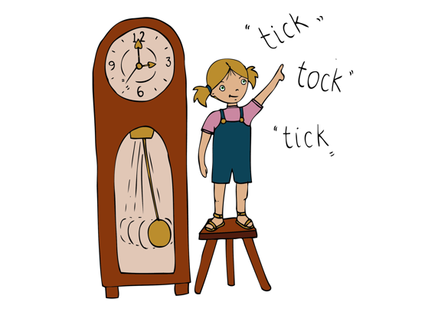
Mmmbop [www.youtube.com/watch?v=NHozn0YXAeE] would work particularly well for this lesson or Oye Como Va [www.youtube.com/watch?v=8NsJ84YV1oA].

- March around the room “in time” to the music (marching on the beat 1, 2, 3, 4). It may be helpful to count aloud “1, 2, 3, 4” and encourage children to match their counting to the movement of their feet. Explain that, instead of doing this, musicians might hear “1, 2, 3, 4” in their thinking voice. March and count in our thinking voices so that we can’t hear the counting out loud.
- Explain that we were marching to the “pulse”. This is a regular beat in the music like a heartbeat.
- Start marching to the pulse again. Teacher calls out “switch” to signal that the children should change the direction of their marching.
- March into a circle. Children to crouch down as you count “1” and stand up on the next “1.” (Crouch, 2, 3, 4, stand up, 2, 3, 4)
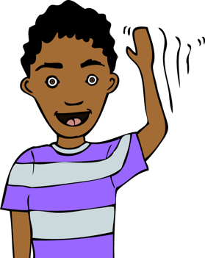
- Teacher move around the circle and say “stay up” to every other child. This means that half the class will stay standing on the first “1” and the other half will crouch. On the second “1” the children will swap over. Encourage children to watch each other carefully to check that their movements match the pulse. This will support children to self-correct if they find this activity challenging.
- Sit down in a circle. Children to turn sideways and tap the pulse on the shoulders of the child sitting next to them. (tap, tap, tap, tap) Encourage children to check that the tap that they can feel on their own shoulders matches the tapping they are doing” This helps children to self-correct. There are several ways to vary this activity and make it more challenging- watch the instructional video to see some examples.

Plenary:
Pulse singing game: Children place left hand on their left knee, palm up. The right hand can now tap the hand of the person to their right. Sing Once I Caught a Fish Alive and tap the pulse on each other’s hands. [www.youtube.com/watch?v=WWCQqesoXV4] Encourage the children to check that they can feel what they are giving as they tap.

Alternatively, sing a song already learnt from SingUp and tap the pulse on knees.
Keywords / vocabulary: Duration (pulse), 4 beats in a bar, 1, 2, 3, 4, thinking voice.

Self-assessment opportunities:
- I can understand that the pulse is a regular beat that I can feel but not always hear.
- I can march and tap the pulse by counting “1, 2, 3, 4” in my thinking voice.
- I can use my entire body to internalise the pulse.
- I can watch other learners carefully to check that I am tapping/crouching/marching at the same time as them.

Resources: Rhythm Card Starter Bank.

Opportunities for sharing work e.g. by recording, notation: N/A

Music Assessment: Year 3 and 4 Rhythm Lesson 1

You only need to note the names of children who are working towards or well above the criteria for the lesson. It will be assumed the majority of the class will achieve the objectives and you don’t need to record this. Use the space below for any specific notes on achievement or evaluation of class progress.

Names of any children who do not meet the learning objectives for this lesson | ‘I can’ assessment criteria | Names of any children who exceed the learning objectives for this lesson.
- I can understand that the pulse is a regular beat that I can feel but not always hear.

- I can march and tap the pulse by counting “1, 2, 3, 4” in my thinking voice.

- I can use my entire body to internalise the pulse.

- I can watch other learners carefully to check that I am tapping/crouching/marching at the same time as them.

Notes:

