Music Lesson Plan topic - Air

Lesson 6 of 6 Focus: Year3/4
Key Learning Objective:
- To perform and evaluate and complete the Hot Air Balloon composition.
Other Learning objectives:
- To sing expressively.

Inter related music dimensions covered: Dynamics, structure, notation, texture, timbre, pitch.

Starter Activity:
Rehearse then perform Part 1 of the Hot Air Balloon song with expression.

Main activity:
Brief rehearsal time with original scores, with a view to performing the children’s final compositions.
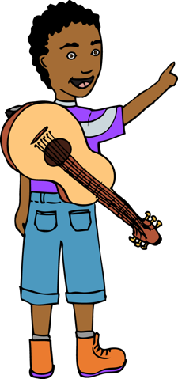
Explain to the class that we are going to become a critical audience for each group’s final performance. Ask children “how will we know if the performance has been a success?” Using children’s answers, create a list of success criteria for children to use as positive peer assessment (e.g. I heard one piano section and one forte section, the performers moved between sections together). Revisit the ‘I can’ statements from the previous lesson.

Plenary: Listen to the final performances and discuss the strengths of each composition using the success criteria. Encourage children to start feedback with “I could hear…”. Each child should write a snapshot written review of what they have achieved, beginning ‘I can’ maybe on a ‘post-it’

Keywords / vocabulary: Dynamics, texture, forte, piano, staccato, legato, notation, score.

Extension opportunities: Perform the ‘Hot Air Balloon’ song and the group compositions to a partner class in an assembly.
Self-assessment opportunities:
- I can suggest improvements to a performance of my composition, using the appropriate vocabulary.
- I can perform by reading and interpreting a graphic score as part of a group performance.
- I can maintain an individual part in a group ensemble performance.

Resources: Class set of percussion instruments. Graphic scores from previous lessons.

Opportunities for sharing work: Record final performances for evidence, both audio samples and pictures of the scores.

Music Assessment: Year 3/4 Air Lesson 6
You only need to note the names of children who are working towards or well above the criteria for the lesson. It will be assumed the majority of the class will achieve the objectives and you don’t need to record this. Use the space below for any specific notes on achievement or evaluation of class progress.

Names of any children who do not meet the learning objectives for this lesson | ‘I can’ assessment criteria | Names of any children who exceed the learning objectives for this lesson.
I can suggest improvements to a performance of my composition, using the appropriate vocabulary.

I can perform by reading and interpreting a graphic score as part of a group performance.

I can maintain an individual part in a group ensemble performance.
Notes:

