Music Lesson Plan topic - Air

Lesson 5 of 6 Focus: Year 3/4
Key Learning Objective:
- To complete composing the soundscape and notate on graphic score.
Other Learning Objectives:
- To choose a location and represent it through notated symbols and with a particular dynamic.

Inter related music dimensions covered: Structure, notation, pitch, dynamics.

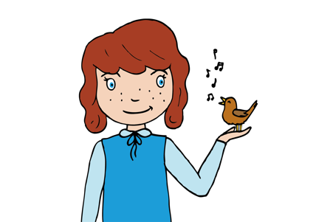
Starter activity:
Revisit ‘Hot Air Balloon’ song. Focus on the direction of the pitch of the melody. Does it move in steps or leaps? Does it cover a wide or narrow range of notes? Is it high or low? Sing the song asking the children to use their hands to map the pitch of the first verse (going up as the melody goes up etc.).

Main Activity:
Recap scores so far. What sections are missing? Each group to select a second location over which their hot air balloon can travel. Tell children that it must be the opposite dynamic (forte – loud /piano - quiet) to their other location.

Each group to create their second location and record on their graphic score sheets. To scaffold, remind children to “catch the sound” before throwing it onto the paper. After this groups compose the ‘landing’ of their balloon.

Once the graphic scores are complete, allow children to attempt a run through of their whole score. At this point ask children “how will you know which section to play as a group?” (Children to use their own ideas, which might be using signals within the group, selecting a child to conduct or counting in their heads how long each section is played). Evaluate group compositions as a class using the ‘I can’ statements from the self-assessment below.
Plenary:
Watch helicopter string quartet www.youtube.com/watch?v=13D1YY_BvWU.
Highlight musicians using a score to know what to play and ask “how are they recreating the sounds of a helicopter?” Stockhausen was a German composer 1928-2007. The Helicopter Quartet is one of Stockhausen’s most outrageous and incredible works, performed by four musicians, one in each of the four helicopters, who keep in sync with each other by monitors. The whole piece last 30 minutes with the helicopters hovering in the sky - the sound of the rotor blades adding to the music - as a long series of string tremolos (based on complicated formulae set forth by Stockhausen) are played over and over. Alongside the graphic score the composer listed these requirements for a performance of the piece: 4 helicopters with pilots and 4 sound technicians, 4 television transmitters, 4 x 3 sound transmitters, auditorium with 4 columns of televisions and, 4 columns of loudspeakers sound projectionist with mixing console. Example of the graphic score can be found in the resources.

Keywords / vocabulary: Signals, score, conductor, notation, dynamics forte/piano (loud/soft), pitch (step, leap) timbre.

Extension opportunities: Ask children to perform another group’s composition using their score as a guide. What is easy, what is difficult?

Self-assessment opportunities:
- I can suggest appropriate sounds and instruments to create a score.
- I can create symbols to represent sounds.
- I can use dynamics.
- I can perform with a sense of ensemble.
- I can read a score to help me follow a performance.
- I can use appropriate vocabulary (forte, piano, legato, staccato, notation, dynamics, pitch, timbre) to describe a performance.
Resources: Blank and Example Graphic Score .pdfs. ‘Hot Air Balloon’ song, Earth, Sea and Sky Resource. Helicopter String Quartet Graphic Score.

Music Assessment: Year 3/4 Air Lesson 5
You only need to note the names of children who are working towards or well above the criteria for the lesson. It will be assumed the majority of the class will achieve the objectives and you don’t need to record this. Use the space below for any specific notes on achievement or evaluation of class progress.

Names of any children who do not meet the learning objectives for this lesson | ‘I can’ assessment criteria | Names of any children who exceed the learning objectives for this lesson.
I can suggest appropriate sounds and instruments to create a score.

I can create symbols to represent sounds.

I can use dynamics

I can perform with a sense of ensemble

I can read a score to help me follow a performance

I can use appropriate vocabulary (forte, piano, legato, staccato, notation, dynamics, pitch, timbre) to describe a performance.
Notes:

