Music Lesson Plan topic - Air

Lesson 3 of 6 Focus: Year3/4
Key Learning Objective:
- To notate sounds using a graphic score.

Inter related music dimensions covered: Notation, dynamics, texture, timbre.
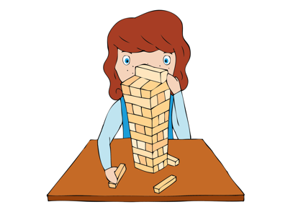
Starter activity: Children sit in the same groups as last week.
Ask one group to perform their soundscape from the previous lesson. Can they remember which instruments they used, sequences of who played when, dynamics, what they played etc.? Was this difficult? Why? Was the performance exactly the same as last week?

Main activity:
Watch one or two recordings from the previous session. Ask children “How could we make sure that what we do is the same each time we perform?” Introduce the idea of a ‘graphic score’ being the visual representation of music/sounds. (This could be musical notes or any other type of mark (symbol) making).

Model graphic score activity: Select a group to play their soundscape from last week. Using sugar paper, model the sounds you hear using mark making (See example in the ‘Hot air balloon’ sections of the score resource for Lesson 4). Encourage children who are not performing to ‘catch’ a sound they hear and imagine throwing it on to the paper, what symbols would they see? As teacher draws symbols on score, children could make symbols in the air with their fingers. This is called notation.

In pairs children create their own graphic score of their group hot air balloon soundscape (inflating, rising or drifting), using whiteboards or paper. Each group discuss each pairs soundscape and decide which is the most effective and why. Select one ‘score’ from each of the three groups and perform the soundscape so far - inflating, rising, drifting, using the score to help prompt memory of which sounds / instruments to use and when to play them. What sounds are loud (forte), quiet (piano), smooth (legato), short and detached (staccato)?

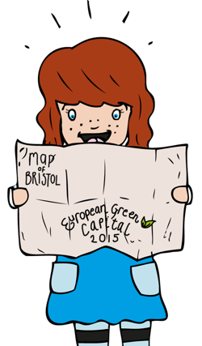
Plenary:
Revisit the ‘Hot Air Balloon’ song. Recognise that this has been notated but not as a graphic score but as staff notation, so a pianist or someone who can read music in this way knows which notes to play. Learn the first verse. Should the song be sung legato or staccato?

Keywords / vocabulary: Score, notation, loud/quiet (forte/piano), legato/staccato (smooth/short and detached).

Extension opportunities: Extend by asking children to work in pairs with whiteboards and to create symbols that could represent different sounds for their partner to ‘perform’.

Self-assessment opportunities:
- I can create and interpret simple graphic scores and recognise that music can be written as staff notation.
- I can compose music as part of a group from different starting ideas.
Resources: Class set of percussion instruments, ‘Hot Air Balloon’ song – Lin Marsh in Earth, Sea and Sky resource.
Opportunities for sharing work: Videos from last week.

Music Assessment: Year 3/4 Air Lesson 3
You only need to note the names of children who are working towards or well above the criteria for the lesson. It will be assumed the majority of the class will achieve the objectives and you don’t need to record this. Use the space below for any specific notes on achievement or evaluation of class progress.

Names of any children who do not meet the learning objectives for this lesson | ‘I can’ assessment criteria | Names of any children who exceed the learning objectives for this lesson.
I can create and interpret simple graphic scores and recognise that music can be written as staff notation.

I can compose music as part of a group from different starting ideas
Notes:

