Music Lesson Plan topic - Air

Lesson 2 of 6 Focus: Year3/4
Learning Objective:
- To create a soundscape with an identifiable structure.
Inter related music dimensions covered: Dynamics, structure, timbre, pitch, texture.
Starter activity: ‘The phone call.’
Sit children in a circle with percussion instruments in the centre and explain that we are going to create a phone conversation without any words! Ask children “what does a conversation involve?” (two people - one talking, one listening - taking turns).

Ask children “how does a phone call begin?” (phone ringing) “What instrument could we use to make a ringing sound?” Child who suggests an instrument can use it to play a “phone ringing” sound to the class (“you say it, you play it!”) Select two children to hold the conversation. (“you say it, you play it!”) Select a fourth child to choose an instrument to be the phone hanging up.
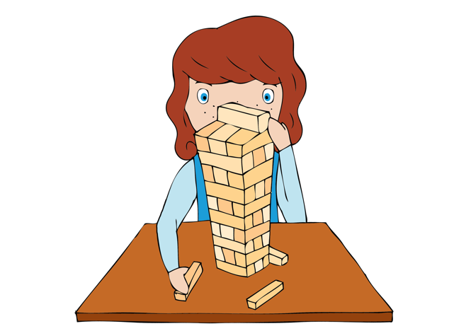
Ask children “what would happen if you all just played at the same time?” Discuss the nature of a conversation and taking turns. Explain that we need to provide ‘structure’ for the conversation to make sense and relate to how instruments work together.

Four children in the centre to play their conversation, taking turns (phone ringing, person 1 speaks, person 2 speaks, person 1 speaks, person 2 speaks, phone hangs up).

Main activity: Group work:
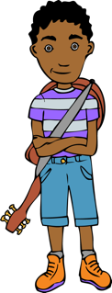
Using ‘Hot air balloon soundscape inspiration’, children create a soundscape of a hot air balloon taking off. Teacher directs each group to work on one section of the structure (inflating, rising up, drifting). Discuss how children who are creating a soundscape of rising up could use pitched percussion (glockenspiel, xylophone) rising up step by step as a scale to depict the idea of rising up. Could you use pitched percussion elsewhere e.g. for birdsong? Use a selection of pitch and unpitched instruments and/or body percussion. Recap dynamics (loud / soft) and ask children to include these in their soundscape.

Plenary:
Performance opportunity. Groups to perform their soundscape to the class. Audience to try to identify which section they have focussed on (inflating, rising, drifting). Record group soundscapes as a video, as they will be used to form a part of a hot air balloon composition.
Revisit Hot Air Balloon song from last week. Rehearse Part 1 of the refrain – can children memorise the words of the refrain? Can they get slightly louder as the melody rises in the first line?
Keywords / vocabulary: Structure, soundscape, compose, composition, loud/quiet (forte/piano), pitch, scale.
Extension opportunities: Listen to and learn the second part of the refrain of ‘Hot Air Balloon’.
Self-assessment opportunities:
- I can make up short musical patterns in a group or on my own using different instruments or sounds to reflect aspects of a balloon journey.
- I can change the way I play an instrument, learning and applying skills and techniques, in order to achieve different effects.
- I can compose music as part of a group from different starting ideas.
- I can sing simple songs as part of a group with expression.
Resources: ‘Hot air balloon soundscape inspiration’ page. Class set of percussion instruments.
Hot Air Balloon song – Lin Marsh in Earth, Sea and sky resource
Opportunities for sharing work: Record small group soundscapes.

Music Assessment: Year 3/4 Air Lesson 2
You only need to note the names of children who are working towards or well above the criteria for the lesson. It will be assumed the majority of the class will achieve the objectives and you don’t need to record this. Use the space below for any specific notes on achievement or evaluation of class progress.

Names of any children who do not meet the learning objectives for this lesson | ‘I can’ assessment criteria | Names of any children who exceed the learning objectives for this lesson.
I can make up short musical patterns in a group or on my own using different instruments or sounds to reflect aspects of a balloon journey.

I can change the way I play an instrument, learning and applying skills and techniques, in order to achieve different effects.

I can compose music as part of a group from different starting ideas.

I can sing simple songs as part of a group with expression.
Notes:

