Music Lesson Plan topic – Chronology

Lesson 5 of 6 Focus: R/1/2
Key Learning Objective:
- To explore, recognise and respond to features of a piece of music from the 20th century.

Inter-related music dimensions covered: Pitch, timbre / tone colour.

Starter activity:
Play the clip of the birdsong to the children.
https://www.youtube.com/watch?v=mfFldO-B8vE See how many birds the children can remember from the clip and write them one the board. Tell the children that they are going to try and remember one of the birdsongs from the clip, and then all together, as a class, they will make a “bird orchestra”! Listen again to a few of the birds then ask a few confident children what their bird is and if they can sing the song for the class. Children all make their bird noises at once.

Main focus:
Explain to the children that today they will be exploring a piece of music that was written to sound like different types of birdsong! The composer who wrote this piece was a composer called Olivier Messiaen (1908-1992) and the piece is called ‘Oiseaux Exotiques’ which means ‘Exotic birds’ in French. He wrote his music for piano and wind ensemble in the 20th century, about 60 years ago. When he was writing this music, some of your grandparents were just babies! Put his picture on the timeline. He was from France – does anyone know where that is? Put his picture on France on the composers map.

These two clips should be played and very briefly discussed as the children just get a taste of the music before the activity, where it will be played repeatedly.

Play the youtube clip https://www.youtube.com/watch?v=9QdgUJss9BU to show Messiaen talking in French (with subtitles) about the different kinds of birdsong that he has written as music. How is this music like birdsong? The sounds are repeated, there are a lot of spaces (rests) between each song, in some cases there isn’t really a ‘tune’, all the birdsongs are quite different from one another etc.

Play a clip of the piece (‘Oiseaux Exotiques’) https://www.youtube.com/watch?v=JHs55Z0OdgU and tell the children to close their eyes as they listen carefully and put up their hand when they hear music that sounds like birdsong. Think about what instruments may be being used. (Piccolo, flute, oboe, clarinet, bass clarinet, bassoon, horn, trumpet, piano, glockenspiel, xylophone, temple block, wood block, snare drum, gongs and tam tam). Skip through it to hear different sections as it is quite a long piece.

The children should discuss the music with their talk partners. Is different from music they have heard before? How so? Do they like it? Why or why not? Explain that composers who wrote at this time (20th century) often made their music sound very different from the other music that had been written before, because they wanted to create music that wasn’t like all the other music in the past. The story of music in the twentieth century is one of exploration and experimentation leading to new trends, new techniques and in some cases entirely new sounds which were often not as melodic as in the past. Did the children hear any sounds that they recognised as birdsong. Birds in the piece include the Minah Bird, Wild Canary, Mocking Bird, Purple Finch, White Crowned Sparrow, Musician Wren, Meadow Lark and Laughing Thrush. There were 38 different species in the whole piece!

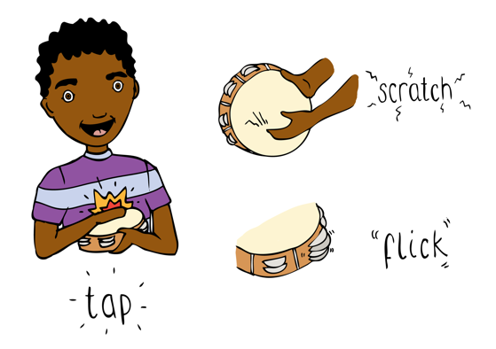
Tell the children that an interesting fact about this composer was that he had something called “Synaesthesia” which is a condition in your brain that means that when you hear a pitch/note, you see a colour as well as hearing the note! (So sound is represented by tone colour). Wouldn’t that be amazing to hear the music AND see the colours of it as well! Play a single note on a glockenspiel or on a piano and hold up a coloured card to demonstrate what you might see when you hear a pitch. This might be what Messiaen saw while he heard music. Then play another one and hold up another coloured piece of card. Ask a child come up and hold up whatever colour they think a note represents when you play one. Now have a child come and play a note on an instrument and another child should hold up a colour to represent it.

Tell the children that today they are going to explore how their brains might see colours when music is heard, just like Messiaen, they are going to be ‘painting’ the music as they hear it. Model this briefly by putting the music on again and showing the children that when you hear a sound, you think about whether it is a high sound, a low sound, or a middle sound, and then paint it on the paper with whatever colour you might ‘hear’. The children should create one sheet of one colour/shade wash and then a second where they use colours over black and white copies of different birds to represent the ‘colour’ of each bird. Remind the children that this is a listening and responding task, and so they need to be as quiet as mice so that everyone can listen to the music. Keep the piece going on repeatedly as the children paint.

Plenary:
Have an ‘art gallery’(as the music is still playing) where the children quietly walk around (remind them that in museums and galleries, everybody is respectfully quiet). Can they remember the name of a) this piece and b) the composer?
Opportunities for mastery: When you are modelling painting the music, think about whether the notes might be bouncy (dots), flowing (long flowing lines), circular (round and round), jagged (angular) and discuss this with the children. Can the children add this detail in black pen as graphic score to their colour art from last session.
Encourage the children to sample some birdsong an bring in an mp3 file
Using mainly tuned percussion create a class sound collage of bird song. The children can give their bird a name / draw their bird real or imaginary and try tonotate their song as a graphic score.
Keywords / vocabulary: 20th century music, Messiaen, Synaesthesia, graphic score, bird song, repetition, rest, melody, pitch, wind ensemble, piano, timbre / tone colour – sound or note colour.

Self-assessment opportunities:
- I can recognise aspects of 20th century music.
- I can respond creatively to 20th century music through the use of colour.

Resources: At least one tuned instrument – piano, glockenspiel, etc. A variety of different coloured card, big enough for the whole class to see. Paints (or other kinds of colouring tools) and A3 Cartridge paper, timeline, 2 pictures of Messiaen, map, You Tube clips, black pens

Opportunities for sharing work e.g. by recording, notation: Children’s artwork in response to the music. Children’s bird song collage.

Music Assessment: R/ Year 1 and 2 Chronology Lesson 5
You only need to note the names of children who are working towards or well above the criteria for the lesson. It will be assumed the majority of the class will achieve the objectives and you don’t need to record this. Use the space below for any specific notes on achievement or evaluation of class progress.

Names of any children who do not meet the learning objectives for this lesson | ‘I can’ assessment criteria | Names of any children who exceed the learning objectives for this lesson.
- I can recognise aspects of 20th century music

- I can respond creatively to 20th century music through the use of colour
Notes:

