Music Lesson Plan topic – Chronology

Lesson 4 of 6 Focus: Year R/1/2
Key Learning Objectives:
- To listen with focus and understanding to a well-known piece of Nationalistic music.
- To make a personal response through movement or art work to the dramatic mood of the music.
- To discuss how the inter-related dimensions of music are used to create the dramatic mood.
Inter-related music dimensions covered: Dynamics, tempo, pitch, texture.

Starter activity:
Tell/read the story ‘The Bear Hunt’ by Michael Rosen to the class or use Michael Rosen’s performance of it from youtube. https://www.youtube.com/watch?v=0gyI6ykDwds.
Divide the class into groups of around 4-5 and provide them with a selection of tuned and un-tuned percussion instruments. Tell the children that they are going to provide the ‘soundtrack’ or musical accompaniment to the story.
Give the children a few minutes to explore and discuss the sounds that they can create on the instruments together and ask them to feedback and play the sounds they create. Allocate sections of the story to each group; they could all join in with the repeated chant ‘We’re going on a bear hunt’ etc. The children should choose suitable instruments to match the sounds suggested by their section of the story. Ask each group why they have chosen the particular sound/timbre to represent the movement through the grass/river/woods etc.

Main focus:
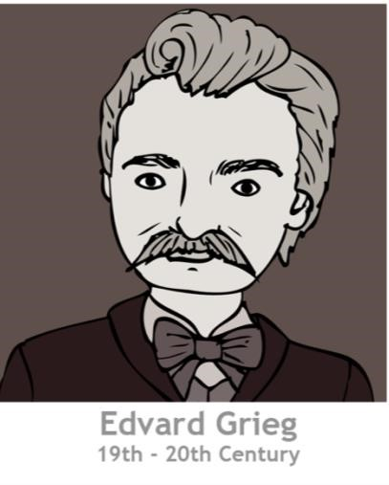
Watch http://www.bbc.co.uk/programmes/articles/1rpRf1Q7cK683F9LlwqTb5x/in-the-hall-of-the-mountain-king-by-edvard-grieg and explain that we are now going to listen to a piece of music by a man called Edward Grieg (1834-1907), who lived just over 100 years ago. Grieg lived in Norway (put his picture on the map and time line) and was part of the Nationalistic movement of music that occurred during the Romantic period. This meant that his music had strong links with the traditions of his country. In Norway there are lots of huge mountains and there are legends about creatures called ‘trolls’ who often lived inside the mountains or in other lonely places. The trolls usually supposed to be ugly, not very clever and they didn’t like humans. Grieg was asked to write some music for a play- just as now people today write music for films and for the theatre. The play was called ‘Peer Gynt’ and was based on a Norwegian folk tale.
In the story the main character Peer Gynt is captured by trolls and brought to the hall of the mountain king. The king wants him to marry his daughter but to do that Peer would have to become a troll. Peer refuses and is chased by the trolls, but luckily manages to escape.
‘In the Hall of the Mountain King’ is from a suite of pieces called ‘Peer Gynt’. Listen to (without looking at the visual clip) https://www.youtube.com/watch?v=PBsFYKzhk5E Whilst you are listening, imagine what the hall looks like. What will the trolls do? How will Peer escape?
Questions to ask after the clip: How did the music make them feel? excited/scared/threatened/worried/nervous?
How do they think Peer would move to avoid the trolls? Take ideas and demonstrations of actions e.g. creep/ jump/run/ duck/dodge/twist. What sort of obstacles might be in his way? How do they think the trolls would move?
If space allows: Pupils work in pairs with one being Peer and the other a troll in order to act out a non- contact sequence of moves to represent the ‘troll’ pursuing Peer. Reinforce the importance of changing actions and directions and of listening to the tempo of the music. Do they remember whether the music begins fast or slow? Repeat the opening section of the music (0.00-0.52) and ask pupils to put their actions to the music. Pause music at times to point out different actions within the class. (If space is restricted choose a couple of pupils to ‘freeze frame’ some actions.)
How does the music create the mood? Take suggestions.
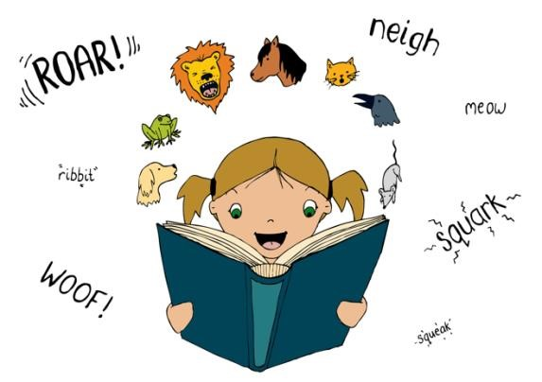
Revise the terms dynamics (forte -loud, piano – soft, crescendo - gradually getting louder) and tempo(fast/slow). Would Grieg have created the same tension if he had kept the same tempo or the same level of dynamics/volume throughout? If time allows give pupils the opportunity to complete their ‘chase’ sequence, matching their movements as the music gets faster. How will they end their dance- with Peer collapsing exhausted on the floor/ punching the air showing victory/rolling down the mountainside etc?
Did the piece start with low or high pitched instruments? (Low) How did this contribute to the effect?(mystery)
Did the children notice anything about the melody? (The melody is constantly repeated using different instruments.) Does the melody move first in steps or leaps? (steps) Could they recognise a simple notation of the melody? http://downloads.bbc.co.uk/tv/tenpieces/arrangements/grieg_gd45__bassoons.pdf (bar 6 is the ‘tune’)
In the classroom extend to a cross curricular art activity. Pupils to draw/paint their own impressions of the hall/ the king/the trolls. Play the music whilst pupils make preliminary sketches.

Plenary:
This performance of ‘The Hall of the Mountain King’ was given by the Warsaw Philharmonic Orchestra.
Music from the Romantic period used large orchestras to express ideas. How does using a large orchestra add to the drama? The huge range of notes of newly developed instruments creates interesting and atmospheric textures. See http://www.bbc.co.uk/programmes/articles/1rpRf1Q7cK683F9LlwqTb5x/in-the-hall-of-the-mountain-king-by-edvard-grieg

Watch the youtube clip again and make a list of all the different instruments that they recognise. (double bass, bassoon, clarinet, ‘cello, violin, oboe, flute, percussion, horn, trumpet, trombone, tuba, timpani, cymbals).

Opportunities for mastery:
Ask the children to put some appropriate words to the first two phrases of the music. Their lyrics should reflect what it is like in the hall or how Peer is feeling? (I am feeling very scared, very scared, very scared, I am feeling very scared I want to run away!)
Could they suggest a different story that would fit the music- e.g. Jack sneaking into the giant’s castle to steal the hen/harp, or the wolf entering the house of Little Red Riding hood’s Grandma.
Listen to ‘Morning’ It is another piece in the same suite as Peer Gynt The melody is played alternately by the flute and the oboe, the strings depict sunrise and then woodwind instruments songs of the birds. Compare the feelings it provokes to the previous music and discuss how the musical element are used to create a very different feeling.
https://www.youtube.com/watch?v=SS7-Gwz1Zio
Keywords / vocabulary:
Pitch, tempo, dynamics (forte,piano / loud,soft), timbre, melody, Romantic Period, Nationalistic, mood, tension, drama, story, suite – a group of pieces
Self-assessment opportunities:
- I can describe how a composer has been inspired by stories/traditions of his/her own country.
- I can respond to the mood of a piece of music with appropriate actions/illustrations.
- I can talk about how the inter related music dimensions can be used to create different effects.

Resources:
- A large space e.g. hall with access to online music.
- Youtube clip of Bear Hunt and/or copy of the book.
- Tuned and untuned percussion.
- Youtube and BBC Ten Pieces clips of ‘Hall of the Mountain King.’
- Paper and art materials.
- Youtube clip of ‘Morning.’.
Opportunities for sharing work e.g. by recording, notation: Recording/performance of Bear Hunt story with instruments. Possible KS1 presentation.
Video recording of pairs acting out the chase sequence. Photos of ‘freeze frames’ with captions.
Pupils’ own pictures of characters from the story.

Music Assessment: Year R/1/2 Chronology Lesson 4
You only need to note the names of children who are working towards or well above the criteria for the lesson. It will be assumed the majority of the class will achieve the objectives and you don’t need to record this. Use the space below for any specific notes on achievement or evaluation of class progress.

Names of any children who do not meet the learning objectives for this lesson | ‘I can’ assessment criteria | Names of any children who exceed the learning objectives for this lesson.
- I can describe how a composer has been inspired by stories/traditions of his/her own country

- I can respond to the mood of a piece of music with appropriate actions/illustrations

- I can talk about how the inter related music dimensions can be used to create different effects.
Notes:

