Music Lesson Plan topic - Water

Lesson 6 Focus: KS1

Key Learning Objective:
- To sing expressively.
Other Learning Objectives:
- To listen with concentration to a range of high-quality music.
- To appreciate how the inter-related dimensions of music ‘work together’ in a composition to create an atmosphere or effect.

Inter related music dimensions covered: Pitch, duration (rhythm), dynamics, tempo, timbre, structure.
Warm up /Starter activity:
Return to vocal warm up as in lesson 4. Sing ‘Big boats, small boats’ song and record. Link key words to performance, sing rhythmically, with good pitching of leaps and scales, express the song through contrasting dynamics.

Main activity:
In Bristol we are very fortunate to have many talented artists and musicians. The music for this lesson has been composed by David Poore, a composer from Bristol who has written many acclaimed film and TV titles from the BBC’s Spring Watch, Grand Designs, Aardman animations to Disney films and the National Geographic Channel. www.davidpoore.com He has very kindly given permission for us to include his music in our Bristol scheme.

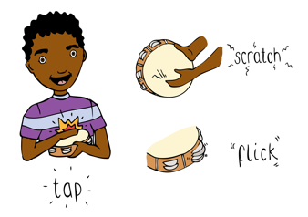
The first track to play the children is one called ‘Salmon Rapids’. Encourage the children to share their thoughts on how the music makes them feel and what it makes them think of. Listen to the opening; it is hard to feel a pulse. This is the river before the salmon appear. As the music develops you can hear a violin playing a ‘pitter, patter’ rhythm. Discuss the journey of salmon swimming up a river and the busyness of the movement of all the salmon swimming together upstream.

Compare and contrast how the interrelated dimensions are used in this and ‘Memories of the River’ by David Poore. Feel the pulse, tempo (slow) dynamics (swelling waves), pitter patter rhythm of the harp and the constant movement of the music representing the flowing water. Look for adjectives to describe both pieces of music. Smooth, long phrases illustrating water’s movement. Discuss why the instruments have been chosen and how their timbres (tones colours) contribute to creating the effects heard.

Plenary:
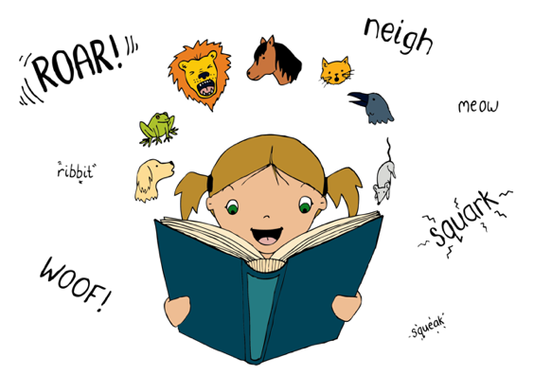
Perform the Pirates! song. Add actions. Link this to the listening by focussing on how the inter-related dimensions of music will contribute to a lively expressive performance, just as they created a mood for each of the rivers in the listening activity. In order to perform this song there needs to be a focus on maintaining a lively pulse, contrasting dynamics to bring the words to life, performance with a strong sense of rhythm and purpose through use of voice and movement building tension and excitement in the song. Children need to listen to and focus on pitch.

Keywords / vocabulary: Pitch, dynamics - loud/soft , tempo - slow/fast, calm, rapid.

Extension opportunities: Add a percussion pulse to the performance of ‘Pirates!’
Self assessment opportunities: (I can..)
- I can describe music using appropriate vocabulary related to the inter-related dimensions of music.
- I can identify instruments and say how and why they have been used to create an effect or mood.
- I can sing with expression and energy to create a sense of performance.
Resources: ‘Salmon Rapids’ and ‘Memories of the River’ by David Poore. ‘Pirates!’ Song (In Earth, Sea and Sky, resource).
A selection of untuned percussion instruments
Opportunities for sharing work: Create an opportunity for the children to share all that they have created in a mini concert. This could be to parents, or in a school assembly.

Music Assessment: Reception / KS1 Water Lesson 6

You only need to note the names of children who are working towards or well above the criteria for the lesson. It will be assumed the majority of the class will achieve the objectives and you don’t need to record this. Use the space below for any specific notes on achievement or evaluation of class progress.

Names of any children who do not meet the learning objectives for this lesson | ‘I can’ assessment criteria | Names of any children who exceed the learning objectives for this lesson.
I can describe music using appropriate vocabulary related to the inter-related dimensions of music

I can identify instruments and say how and why they have been used to create an effect or mood.

I can sing with expression and energy to create a sense of performance.
Notes:

