Music Lesson Plan topic - Water

Lesson 5 Focus: KS1
Key Learning Objective:
- To keep a steady pulse and to play rhythms together.
Other Learning Objectives:
- To feel the pulse whilst listening and internalise the pulse through movement.
- To build an understanding of the pulse and its role as the foundation of music.
- Begin to understand that rhythms are patterns of long and short sounds. The pulse doesn’t change within the context of the song or piece of music but the rhythm does.
Inter related music dimensions covered: Duration (rhythm).
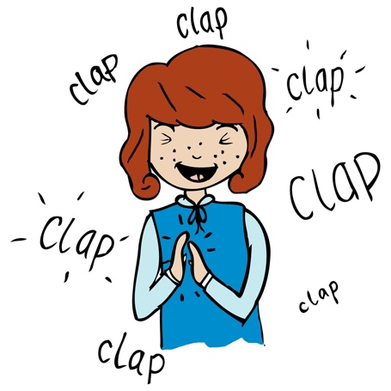
Warm up / Starter activity:
Teacher to clap rhythm of either rain, rain, rain, rain or pitter patter, pitter patter. Children walk on the spot in time to either rhythm. Extend to move around room walking in time. Develop to see if children can walk on the spot – to rain rain etc and clap pitter patter at the same time; then swap. Divide the class so half clap pitter, patter whilst the other half step ‘rain, rain’.

Main Activity:
Continue to celebrate that Bristol has an amazing history with river journeys and expeditions. Begin with chanting a well known rhyme: ‘Rain, rain, go away’. Say this rhyme together rather than singing it.

Discuss the differences between keeping a beat (the pulse) and rhythm. What do the children already know? A beat (the pulse) remains constant, regular and steady throughout a piece of music. The rhythms are patterns made of beats of different lengths. Occasionally, the speed or tempo of the music can change to slow down or to speed up the beat (pulse) of the music.

Teacher keep a steady 4 beat pulse using claves, wooden spoons or sticks. The children should say the lines of Rain, rain go away. Now divide the class into 3 groups as below.
Group 1: Rain, rain, rain, rain (repeat over and over)
Group 2: Go away. Go away (repeat over and over)
Group 3: Please come back another day (repeat)
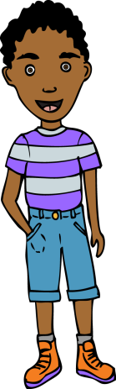
You now have three rhythmic ostinato patterns (small repeating rhythmic patterns)

Begin with Group 1 chanting the first line then bring in the other groups one at a time. This will make it easier rather than everyone starting at the same time to begin with. You can also change the entry order for contrast. Choose untuned percussion instruments such as hand drums, claves, wood blocks, shakers, castanets, tables, chairs, stomp materials etc to change this music from a vocal chant into an instrumental piece. Children play the rhythm of the words on their instruments, maintaining their part whilst feeling the pulse so that the ensemble stays together. Record the music created by the children once the rhythms have become embedded.

Plenary:
Listen again to ‘Big boats, small boats’ (see previous lesson). Whilst listening to the song children feel the pulse by walking in time to the music. Sing the chorus whilst walking in time with the pulse.

Keywords / vocabulary: Pulse, rhythm, beat, steady, pattern, ostinato.
Extension opportunities: To make links with ‘rain rain’ rhythm and ‘Big boats, small boats’. Notice the opening of the chorus ‘big boats, small boats, any kind at all boats is the same rhythmic duration as rain, rain, rain, rain, pitter-patter rain rain. It takes the same amount of time to play/sing rain as it does to play/sing pitter or patter. However the rhythms are different.
Self assessment opportunities: (I can..)
- I can feel the pulse and keep the beat on my own.
- I can copy and play simple rhythms in time with other people.
Resources:
Untuned percussion, ‘Big boats, small boats’ (In Earth, Sea and Sky, resource). Recorder/iPad or digital recorder
Opportunities for sharing work: Through recordings.

Music Assessment: Reception / KS1 Water Lesson 5

You only need to note the names of children who are working towards or well above the criteria for the lesson. It will be assumed the majority of the class will achieve the objectives and you don’t need to record this. Use the space below for any specific notes on achievement or evaluation of class progress.

Names of any children who do not meet the learning objectives for this lesson | ‘I can’ assessment criteria | Names of any children who exceed the learning objectives for this lesson.
I can feel the pulse and keep the beat on my own

I can copy and play simple rhythms in time with other people
Notes:

