Music Lesson Plan topic - Water

Lesson 4 Focus: KS1

Key Learning Objective:
- To use voices creatively and expressively when singing songs.
Other Learning Objectives:
- To understand the importance of warming up voices and adopting good posture.
- To sing songs and melodies musically, pitching high and low notes moving in steps or leaps.
- To have an understanding of singing with a variety of dynamics.
Inter related music dimensions covered: Pitch, dynamics, structure.
Warm up / starter activity:
Allow the children to explore their own singing voices by copying the sounds you make. “I can use my high voice, I can use my low voice”. Pretend to blow bubbles and chew toffee to get their jaws moving. Ask the children to make their faces as small as they can then follow with the largest, biggest, widest face they can possibly make. Encourage pupils to lead this too as they will have their own ideas. Make this section fun and fast paced so the children and you are relaxed and ready to sing. Blow silently to finish, encouraging the children to relax their shoulders whist sitting up so as not to squash their ‘tanks of air’.

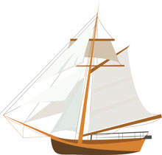
Main activity:
Listen to ‘Big Boats, Small boats’ a song written by Lin Marsh. The songs in this lesson and in lesson 6 are celebrating the many boats that travel to and from Bristol on the River Avon.

- To sing leaps: The song begins with four notes, one for each word. Big boats, small boats. These notes leap down so take the time to learn to sing these leaps accurately. You might like to make the ‘small boats’ sound like an echo and sing these words a little more quietly.
- The next line, ‘Who knows where they’re going ‘cross the deep blue sea’. This is a tricky phrase to sing as there are no breaks in the music. Try to teach this phrase as if it is one line as it will make the sound of the singing less disjointed and much smoother as you are trying to depict the gentleness of the water. Definitely no staccato (bouncy) singing here! If the children can sing this line all in one breath, that would be amazing! Try singing standing up, as it’s much easier.
- The second half of the chorus is very similar to the first. The words have changed to ‘Big ships, small ships’. The melody and rhythm are almost identical apart from the final bar where we hear those leaps again. Raise your hands to show the rise and fall in pitch and encourage the children to copy you.
- Adding actions to learning the words in the verses will help the children remember the song words.
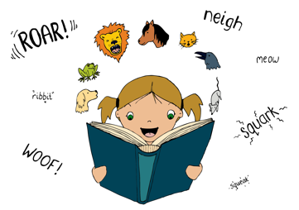
- Add dynamics to add interest to the song. At the end of each verse, there is a crescendo (gradually getting louder), rather than softer. See if your class is able to do this before gently returning to the chorus. Why is there a crescendo here? (to lead back into the chorus).
Plenary:
Watch the Bristol M Shed launch video celebrating Bristol and its history. www.youtube.com/watch?v=uY3hqEYTESM
Notice that this song – like Big boats small boats has a verse and chorus structure. As a class evaluate the performance of the children on the clip.
Keywords / vocabulary: Pitch, intervals / leaps, phrase, dynamics, crescendo (gradually getting louder), mf mezzo forte (moderately loud), mp mezzo piano (moderately quiet), chorus, verse.
Extension opportunities: Adding instrumentation to accompany the song. You could ask several or all of your pupils to play the chords of the song using chime bars, hand bells, glockenspiels or keyboards.
Self assessment opportunities: (I can..)
- I can control my voice to sing with a variety of dynamics.
- I can sing a phrase musically (with no breath in the middle of a phrase).
- I can pitch high and low notes moving in steps or leaps.
Resources:
‘Big Boats, Small boats’ (In Earth, Sea and Sky resource).
Tuned instruments, Digital recorder.
Opportunities for sharing work: Pair up with another class to share singing with them and vice versa.

Music Assessment: Reception / KS1 Water Lesson 4

You only need to note the names of children who are working towards or well above the criteria for the lesson. It will be assumed the majority of the class will achieve the objectives and you don’t need to record this. Use the space below for any specific notes on achievement or evaluation of class progress.

Names of any children who do not meet the learning objectives for this lesson | ‘I can’ assessment criteria | Names of any children who exceed the learning objectives for this lesson.
I can control my voice to sing with a variety of dynamics

I can sing a phrase musically (with no breath in the middle of a phrase)

I can pitch high and low notes moving in steps or leaps
Notes:

