Music Lesson Plan topic - Rhythm

Lesson 6 of 6 Focus: Year R/1/2
Key Learning Objective:
- To read and perform a four bar notated rhythm.
Inter-related music dimensions covered: Duration (pulse/beat), rhythm.

Starter activity:

Children select favourite warm up song to focus the children’s voices, bodies and brains.
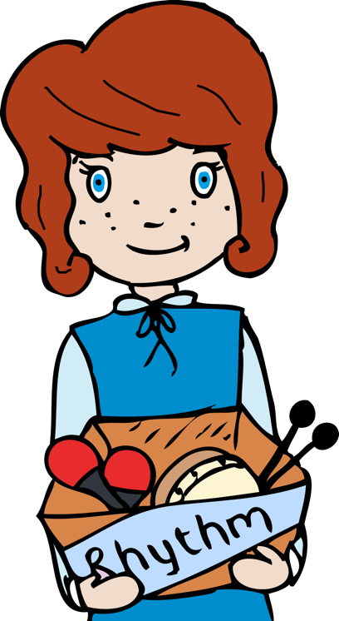
Main Focus:

Give the children a selection of untuned percussion instruments. Display four rhythm grids from the previous week in a line on the board. Children chant the animal rhythms and then play on their instruments. This is a four bar rhythm.

Select one further rhythm as a rhythmic ostinato. Play this again and again as an ostinato. Divide the class in two, half the class play the ostinato. When this is well established add the other half of the class playing the four bar rhythm. Repeat this with different rhythms. These rhythms can be performed to the backing tracks.

Plenary:

Listen again to the piece of music called the ‘Zebra Crossing’ www.youtube.com/watch?v=ayKzmySojM8 played by a group called the ‘Soweto String Quartet’ from Africa. After the initial slow section of music at the beginning, bounce and catch a ball. The ball bounces on beat one and is caught on beat two and held on beat three and four (see video). Extend this to bouncing the ball on beat one to a partner who catches it on beat two and holds it on beat three and four before returning it on the next beat one.

Keywords / vocabulary: Duration, pulse/ beat, rhythm, ostinato, bar.

Self-assessment opportunities:
- I can read and perform a four bar notated rhythm.
- I can maintain a rhythmic ostinato.
Resources: Singup, frog, monkey and alligator pictures, variety of untuned percussion instruments, balls.
Opportunities for sharing work e.g. by recording, notation:

Music Assessment: Year R/1/2 Rhythm Lesson 6
You only need to note the names of children who are working towards or well above the criteria for the lesson. It will be assumed the majority of the class will achieve the objectives and you don’t need to record this. Use the space below for any specific notes on achievement or evaluation of class progress.

Names of any children who do not meet the learning objectives for this lesson | ‘I can’ assessment criteria | Names of any children who exceed the learning objectives for this lesson.
- I can read and perform a four bar notated rhythm

- I can maintain a rhythmic ostinato
Notes:

