Music Lesson Plan topic - Rhythm

Lesson 5 of 6 Focus: Year R/1/2
Key Learning Objectives:
- To compose and perform a four beat rhythm.
- To use this as a rhythmic ostinato.
Inter-related music dimensions covered: Duration (pulse/beat), rhythm.
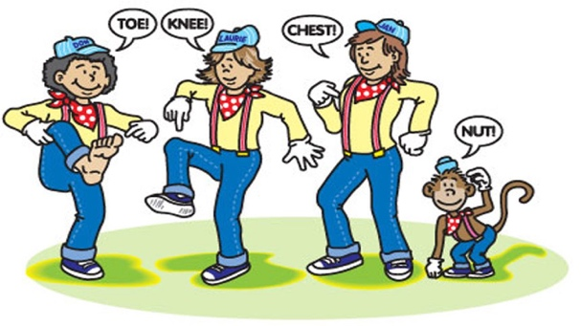
Starter activity:

‘Tony Chestnut’- Revise the song. Children point to the relevant part of the body as they sing e.g. toe, knee, chest, head, nose, eye, hand on heart for love, him – point with finger. Which parts of the song have the rhythm frog, frog, frog, frog (‘To-ny Chest-nut’ and ‘knows I love him’). [www.singup.org]

Main Focus:

Review the rhythm picture cards. Arrange them in a variety of ways and have the children clap/say the rhythms.

Review the meaning of rhythmic ostinato (a short repeated rhythmic pattern). Children create a four beat rhythm using the animal pictures. To do this children select an animal to put in each of the four boxes. Underneath the animal picture, draw the note value. Children try clapping/chanting their rhythm. Half the class keep the pulse, whilst the other half clap examples of the ostinato. Develop this so each animal /note value is performed with different body percussion. E.g. Frog – walking in time, monkey clapping and alligator on knees (alternate hands). These rhythms can be performed to the backing tracks (see resources).

Plenary:

‘This Train is Bound for Glory’ - Sing as before and keep learning the verses, adding a different ostinato on each repetition. [www.singup.org]

Listen again to the piece of music called the ‘Zebra Crossing’ www.youtube.com/watch?v=ayKzmySojM8 played by a group called the ‘Soweto String Quartet’ from Africa. After the initial slow section of music at the beginning, bounce and catch a ball. The ball bounces on beat one and is caught on beat two and held on beat three and four (see video). Extend this to bouncing the ball on beat one to a partner who catches it on beat two and holds it on beat three and four before returning it on the next beat one.
Keywords / vocabulary: Pulse/ beat, rhythm, ostinato.

Self-assessment opportunities:
- I can compose a four beat rhythm.
- I can perform my four beat rhythm.
- I can perform my four beat rhythm and maintain it as a rhythmic ostinato.

Resources: Singup, frog, monkey and alligator pictures, balls, backing tracks.
Opportunities for sharing work e.g. by recording, notation:

Music Assessment: Year R/1/2 Rhythm Lesson 5
You only need to note the names of children who are working towards or well above the criteria for the lesson. It will be assumed the majority of the class will achieve the objectives and you don’t need to record this. Use the space below for any specific notes on achievement or evaluation of class progress.

Names of any children who do not meet the learning objectives for this lesson | ‘I can’ assessment criteria | Names of any children who exceed the learning objectives for this lesson.
- I can compose a four beat rhythm

- I can perform my four beat rhythm

- I can perform my four beat rhythm and maintain it as a rhythmic ostinato

Notes:

