Music Lesson Plan topic - Rhythm

Lesson 4 of 6 Focus: Year R/1/2
Key Learning Objective:
- To compose, perform and maintain a rhythmic ostinato.
Inter-related music dimensions covered: Duration (pulse/beat), rhythm.
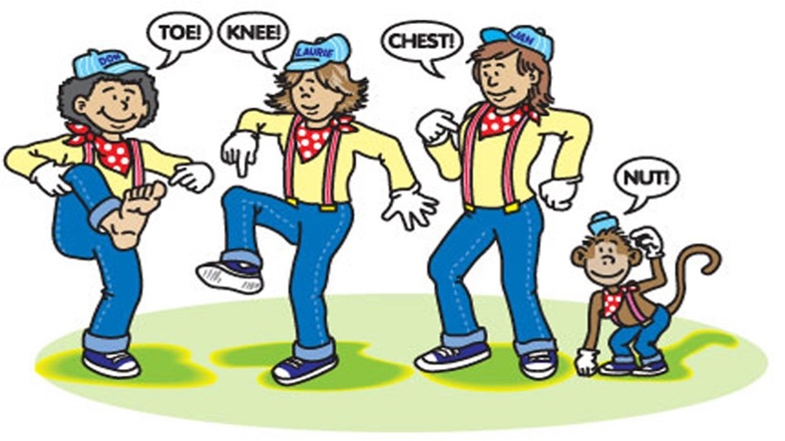
Starter activity:

‘Tony Chestnut’ -Learn the song. Children point to the relevant part of the body as they sing e.g. toe, knee, chest, head, nose, eye, hand on heart for love, him – point with finger. Which parts of the song have the rhythm frog, frog, frog, frog (‘To-ny Chest-nut’ and ‘knows I love him’). [www.singup.org]

‘H.E.L.L.O.’ - Listen again to the chant, feel the pulse by marching in time on the spot. Join in the response using the track on Singup. Extension: Listen as before then split the group in two with one group calling and one group responding. Swap. [www.singup.org]

‘Say Boom Chicka Boom’ – This activity can be extended by saying it in different voices e.g. the Queen, a baby, a witch, a robot, a duck etc. Also you could get ideas from the children. Another idea is to say it using different emotions – e.g.: happy, sad, excited, suspicious, etc. [www.singup.org]

Main focus:

Remind the children about the difference in definition between pulse/beat (constant /regular) and rhythm (a pattern made of beats of different lengths). Give claves out. Show the children the frog and the monkey and have them tap a RHYTHM. Rearrange the pictures and ask the children tap out rhythms that you are ‘composing’.

Introduce the children to additional notation and tell them that we will be thinking of another kind of note value, still using animals from the Bristol Zoo. This time we are using the word and picture “alligator” for four semi-quavers /sixteenth notes. (frog=monkey=alligator).
Show alligator pictures, say “alligator, alligator, alligator, alligator”. How many syllables are there in alligator? 4 and in monkey 2 and in frog 1. Walk the frog pulse and clap alligator note value. Divide the class and ask half to walk frog whilst other half clap alligator. Swap. Do this at a steady pulse.

As before, have a child come up to the front and rearrange the pictures and the rest of the class say them, then clap and say them.
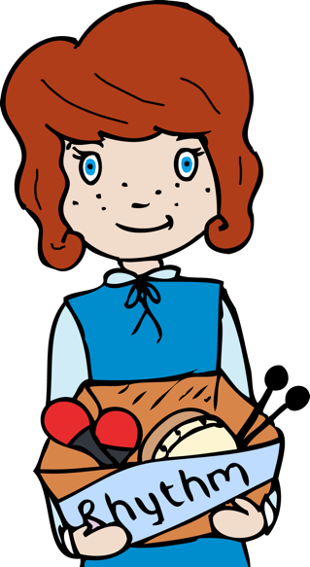
Put one picture of each animal on the board so the children can see. Divide the class into three and listen to This Train [www.singup.org]. One third of the class whisper frog, frog, frog, frog in time to the song. When confident add the next third of the class whispering monkey, monkey, etc and finally add the alligator group. Once all are confident with these whispered note values distribute a few percussion instruments to individuals in the 3 groups (e.g. shakers, tambours/drums and claves). If the class are confident assign a whole group a set of instruments.

Tell the children that when you point to an animal, the group assigned to that animal will have to play their instruments in the rhythm of the animal, using the instruments in front of them. Then switch the groups around so all children have a chance to be all animals. Try and get it rhythmically although it may not come the first time you do this. These rhythms can be performed to the backing tracks.

Plenary:

‘This train’ – Learn the song. When confident add a small group of children using instruments with the rhythmic ostinato patterns (a short repeated rhythmic pattern) that they have learnt (frog, monkey and alligator). [www.singup.org]

Listen again to the piece of music called the ‘Zebra Crossing’ www.youtube.com/watch?v=ayKzmySojM8 played by a group called the ‘Soweto String Quartet’ from Africa. After the initial slow section of music at the beginning, bounce and catch a ball. The ball bounces on beat one and is caught on beat two and held on beat three and four. See video resource.

Keywords / vocabulary: Duration, pulse/ beat, rhythm, ostinato, names of percussion instruments, note values, crotchet (quarter note), quaver (eighth note), semi-quaver (sixteenth note).

Self-assessment opportunities:
- I can explain the difference between pulse/beat and rhythm.
- I can tap/clap/walk/play the pulse/beat and the rhythm.
- I recognise and perform crotchet (quarter note), quaver (eighth note), semi-quaver (sixteenth note).
- I can maintain a rhythmic ostinato.

Resources: Large Space, Singup, frog, monkey, alligator pictures (see resources), Variety of percussion instruments – enough for the whole class to have one, rhythm backing tracks.

Opportunities for sharing work e.g. by recording, notation: N/A

Music Assessment: Year R/1/2 Rhythm Lesson 4
You only need to note the names of children who are working towards or well above the criteria for the lesson. It will be assumed the majority of the class will achieve the objectives and you don’t need to record this. Use the space below for any specific notes on achievement or evaluation of class progress.

Names of any children who do not meet the learning objectives for this lesson | ‘I can’ assessment criteria | Names of any children who exceed the learning objectives for this lesson.
- I can explain the difference between pulse/beat and rhythm

- I can tap/clap/walk/play the pulse/beat and the rhythm

- I recognise and perform crotchet (quarter note), quaver (eighth note), semi-quaver (sixteenth note).

- I can maintain a rhythmic ostinato

Notes:

