Music Lesson Plan topic - Rhythm

Lesson 3 of 6 Focus: Year R/1/2
Key Learning Objectives:
- To identify the difference between pulse and rhythm.
- To recognise, play and compose simple rhythm patterns with the aid of animal note value cards.
Inter-related music dimensions covered: Duration (pulse/rhythm).

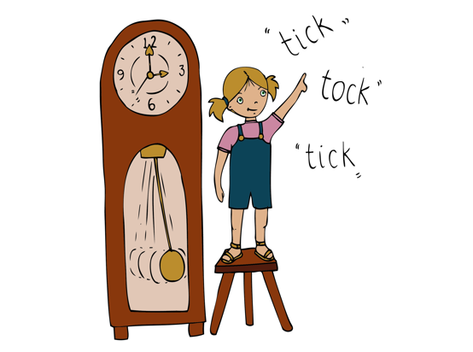
Starter activity:

H.E.L.L.O. - Listen to the chant, feel the pulse by marching in time on the spot. Join in the response using the track on Singup. Extension: Listen as before then split the group in two with one group calling and one group responding. Swap. [www.singup.org]

Listen to the Drum - [www.nancymusic.com/Drum]
Teacher: use a drum or a tambour to play along with the recording. When it comes to the “Listen to the Drum” section, tell children not to clap, just listen. Listen to the rhythm and children clap/echo the same rhythm back. On listening again ask children to keep the pulse/beat by gently tapping their thighs (use a variety of body percussion e.g. tap feet) as well as clapping back the rhythm when it occurs.

Main focus:

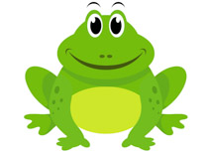
Rhythm is a pattern made of notes of different lengths. Children will make rhythm patterns using two different note lengths. Has anyone ever been to the Bristol Zoo? Has anyone seen frogs there? Show them one frog. Then show them 4 frogs, and all say together to a steady beat/pulse “frog frog frog frog”. Get the children to then say it with you and clap as they say it. How many claps does “frog” have? Relate to syllables. Look at the notated musical note, this is a crotchet/quarter note.
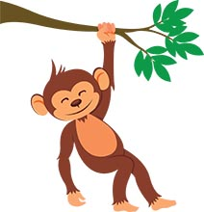

The second picture is a Monkey. Show them the monkey card say “monkey” and clap the rhythm. How many claps does “monkey” have? Then show them 4 monkeys and say “monkey monkey monkey monkey” . Look at the notated musical note, this is a quaver/eighth note. See video resource.

But what if there is a frog and a monkey next to each other? Then we could line them up and say “frog monkey frog monkey” or “monkey frog monkey frog”. Every time you say a rhythm, follow it up by getting the children to tap or clap it as they are saying it. Play around with the frogs and monkeys and ask individual children to clap and say a rhythm as a “solo” if they feel they want to.

Ask a child to come up and “compose” a rhythm using the frogs and monkeys. Everybody chant the rhythms and then both clap and say them together. The “Composer” can choose individual children if he/she wishes.

Plenary:
Listen to Animal Song – Join in with the animal sounds. Children recognise the notation of the monkey chorus using the animal note value cards. [www.singup.org]

Listen again to a piece of music called the ‘Zebra Crossing’ www.youtube.com/watch?v=ayKzmySojM8 played by a group called the “Soweto String Quartet” from Africa. After the initial slow section of music at the beginning, in partners clap own hands together and then clap each other’s hands to the pulse/beat. (1 – own hands together, 2 – partner’s hands, 3 – own hands, 4 – partner’s).

Listen again and this time children whisper counting to four, clapping on beat one and tapping thighs on beats 2,3,4.

Extension: Ask the children to stand up, and they will step on the 1st beat of each bar as they move around the circle. Extend this to stepping on the first beat and clapping on beats 2,3,4.
Keywords / vocabulary: Duration, rhythm, pulse/ beat, note value, crotchet (quarter note), quaver (eighth note).
Self-assessment opportunities:
- I can echo a rhythm.
- I understand the difference between pulse and rhythm.
- I can compose, read and perform a simple rhythmic pattern.
Resources: Large Space, Singup, frog monkey notation resource cards.
Opportunities for sharing work e.g. by recording, notation: N/A

Music Assessment: Year R/1/2 Rhythm Lesson 3
You only need to note the names of children who are working towards or well above the criteria for the lesson. It will be assumed the majority of the class will achieve the objectives and you don’t need to record this. Use the space below for any specific notes on achievement or evaluation of class progress.

Names of any children who do not meet the learning objectives for this lesson | ‘I can’ assessment criteria | Names of any children who exceed the learning objectives for this lesson.
- I can echo a rhythm

- I understand the difference between pulse and rhythm

- I can compose, read and perform a simple rhythmic pattern

Notes:

