Music Lesson Plan topic - Rhythm

Lesson 2 of 6 Focus: Year R/1/2
Key Learning Objectives:
- To feel and internalise the pulse/beat.
- To identify the strong beat and demonstrate with an action/clapping.
Inter-related music dimensions covered: Duration (pulse/beat), rhythm.
Starter activity:
Children stand up and get their voices, bodies, and brains warmed up.
- Warm up and Stomp Canon - Tell the children they will be warming up their voices, bodies and brains with an interactive chant. [www.singup.org]
- ‘Kye Kye Kule’ - A call and response song with actions. [www.singup.org]
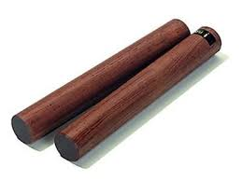
Main focus:

Ask the children if they remember what the pulse/beat is in music. Give them claves (rhythm sticks) and tell them that they are going to try and keep the beat or the pulse of this music with their claves. Remind them that the pulse/beat is a REGULAR beat that you feel but do not hear.

www.nancymusic.com (www.nancymusic.com/Butterplay) click on “Song of the Month” then click on “alphabetically” and then scroll down and click on “Make a bit of butter”. Listen to the song then children sway to the pulse. Use the claves to tap the pulse. Extension: use the claves to just tap on the first beat of four - try moving hands/whisper 2,3,4 on beat 2,3,4.

Play the children a clip of ‘Mmmbop’ by Hansen, this is a very rhythmic and lively pop song. Tell them that you want them to listen out for the pulse/beat, and march on every beat. www.youtube.com/watch?v=NHozn0YXAeE

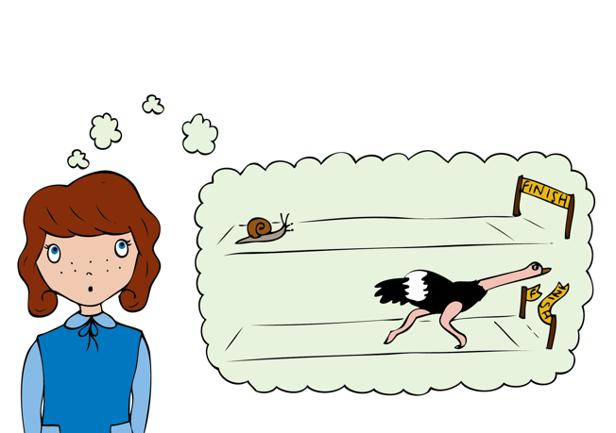
Tell them that when you say “switch” you must switch direction and start marching the other way, not forgetting to march on every beat!

Plenary:
Chant: ‘Say Boom Chicka Boom’ - This activity can be extended by saying it in different voices e.g. The Queen, A baby, A witch, A robot, A duck etc. Also you could get ideas from the children. Another idea is to say it using different emotions – e.g.: happy, sad, excited, suspicious, etc. This is a great activity for saying rhythms to a pulse where the tempo (speed) changes. [www.singup.org]

Listen again to a piece of music called the ‘Zebra Crossing’ www.youtube.com/watch?v=ayKzmySojM8 played by a group called the ‘Soweto String Quartet’ from Africa. After the initial slow section of music at the beginning, in partners clap own hands together and then clap each other’s hands to the beat/pulse. (1 - own hands together, 2 - partner’s hands, 3 - own hands, 4 - partner’s).

Listen again and this time children whisper counting to four, clapping on beat one and tapping thighs on beats 2,3,4.

Extension: Get the children to stand up, and they will step on the 1st beat of each bar as they move around the circle. Extend this to stepping on the first beat and clapping on beats 2,3,4.
Keywords / vocabulary: Duration, pulse/beat, rhythm.

Self-assessment opportunities:
- I can explain what the pulse/beat is.
- I can tap/clap/sway the beat in time with the music and at different speeds (tempo).
- I can identify the strong beat.
Resources: Large space, Claves, Singup.

Opportunities for sharing work e.g. by recording, notation:

Music Assessment: Year R/1/2 Rhythm Lesson 2
You only need to note the names of children who are working towards or well above the criteria for the lesson. It will be assumed the majority of the class will achieve the objectives and you don’t need to record this. Use the space below for any specific notes on achievement or evaluation of class progress.

Names of any children who do not meet the learning objectives for this lesson | ‘I can’ assessment criteria | Names of any children who exceed the learning objectives for this lesson.
- I can explain what the pulse/beat is

- I can tap/clap/sway the beat in time with the music and at different speeds (tempo)

- I can identify the strong beat

Notes:

