Music Lesson Plan topic - Air

Lesson 5 of 6 Focus: Year R/KS1
Key Learning Objective:
To understand Rondo form and to create a class composition based on this structure.
Inter related music dimensions covered: Structure, pitch, duration (rhythm), dynamics, tempo, timbre, texture.
Warm up /Starter activity:
Play the song ‘Little bird’ found on the SingUp website and explain that there are two distinct sections, each with different flying things! (can they tell you what they are? - little bird and my sugar lump) Play it again and this time, when the words “Fly through my window” are sung in the first verse, get the children to clap the rhythm whilst the song is playing.

Talk to the children about what other words can be said to fit the rhythm to “fly through my window”, preferably about birds’/ butterflies/other flying things’ e.g.“Fly in the blue sky”, “soaring and diving”. Add movement to each - ask the children what kind of movement they would put to each idea that they come up with.

Main activity:
Tell the children that they will be having another lesson about kites today, thinking about Bristol’s different weathers and what weather would be best for the Kite Festival!

Ask the children to look outside as they did in previous lessons. What kind of weather is it? Would it be good weather to fly a kite? Why or why not? What is the best weather to fly kites in? What do we need to fly a kite? Has anyone ever flown a kite? What did you like about it? Did you find anything challenging? Show them clip of kite in different weathers www.youtube.com/watch?v=kLTyXlcvDFI

Talk to the children about how the music changes depending on what the weather is, and what the kite is doing. They might notice it gets faster and more dramatic when the kite is going through a storm, and that the music sounds slow, happy and peaceful when it is in the sunshine. You could see if the children can identify the different instruments (flute, piano) and talk about how they are used to portray certain moods.

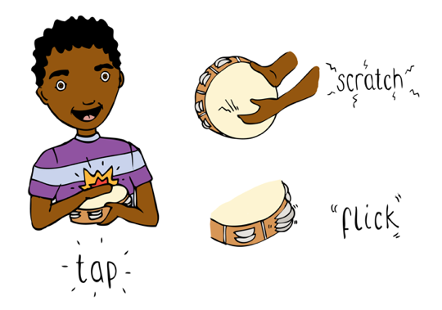
Divide the class into five groups and allocate each a different theme; A kite theme, B windy weather, C gentle rain, D stormy weather and E calm weather. Provide each group with a box of instruments from which the children can choose those which suit their ‘weather’. Encourage pupils to explore timbre. (You could choose to give each table a box containing only one type of instrument to encourage them to explore different ways of creating contrasting sounds from the same instrument). Bring the class back together and each group perform their ‘weather’ without divulging what it is. The rest of the class have to give reasons as to what they think the weather is and why.

Listen to the third movement of Haydn’s ‘Trumpet concerto in E flat’. www.youtube.com/watch?v=hb5MSJcBb9o. Notice how the theme returns again and again, just like the kite. Children can put their hands up to indicate where they hear the returning theme. How many times does it occur? (10 times although sometimes only in part).

Plenary:
Now create a Rondo structure (ABACADAEA). The Kite is theme A and returns again and again. Discuss why theme A returns – it is the focus of the piece. A Rondo is a musical structure where the theme keeps returning. Rehearse, perform and record the class Rondo.

Keywords / vocabulary: Theme, rondo, timbre, repeat, graphic score, dynamics, tempo, flute, piano, trumpet, concerto (a piece for soloist and orchestra).

Extension opportunities:
To notate their ‘theme’ as a graphic score. Photocopy theme A and then build the rondo visually as a display.
Learn Kite Song. This could then become the A theme in a class Rondo using the other ‘weather’ themes.
Self-assessment opportunities: (I can..)
- I can compose and perform within a given structure.
- I can recognise a repeated theme.
- I can select appropriate timbres to represent an idea.
Resources: Youtube links, ipad or alternative for recording, instruments, Kite song (in resources).
Opportunities for sharing work e.g. by recording, notation.

Music Assessment: Reception / KS1 Air Lesson 5

You only need to note the names of children who are working towards or well above the criteria for the lesson. It will be assumed that the majority of the class will achieve the objectives and you don’t need to record this. Use the space below for any specific notes on achievement or evaluation of class progress.

Names of any children who do not meet the learning objectives for this lesson | ‘I can’ assessment criteria | Names of any children who exceed the learning objectives for this lesson.
I can compose and perform within a given structure

I can recognise a repeated theme

I can select appropriate timbres to represent an idea.
Notes:

