Music Lesson Plan topic - Air

Lesson 3 Focus: R/KS1
Key Learning Objective:
- To create symbols that represent musical sounds and notate them as a graphic score.
Other Learning Objective:
- To feel and internalise the pulse in the context of an action songs.
Inter-related music dimensions covered: Pitch, duration (rhythm), dynamics, tempo, timbre, structure, notation – graphic scores.
Warm up /Starter activity:
‘John Kanaka’ Warm up (Resources on SingUp)
Listen to the performance track until everyone is familiar with the melody.
Children stand in pairs, in two concentric circles. Perform the following actions:
o I heard, I heard the old man say: children link left elbows with their partner from the outside/inside circle and walk round on the spot in time to the pulse
o Today, today’s a holiday: as above but link right elbows and walk the opposite way
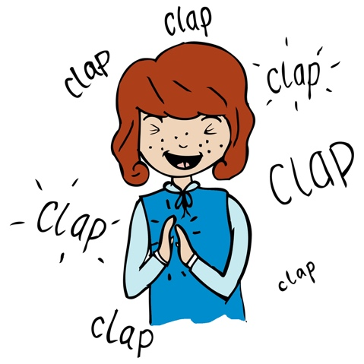
o John: stamp right foot
o Kanakanaka: slap knees in rhythm (ka-na-ka-na-ka)
o Toolee: clap hands twice
o Ay: clap both hands of your partner
Once the verse is sung, the children in the outer circle move one step to the left and face a new partner. Repeat the song.

Extended activities for warm up:

Ask the children to sing the word ‘John’ in their ‘thinking voices’ whilst still doing the action. With each new verse, put more words into the thinking voice until the whole song is being sung in the thinking voice. The actions are still being performed, creating a wonderful percussive sound.

Main activity:
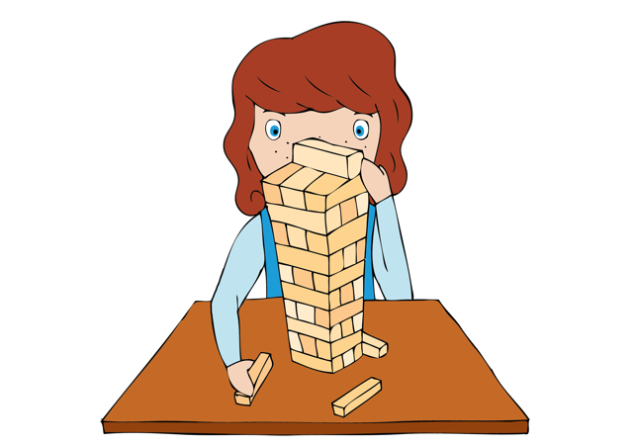
Introduce the children to the concept of a Graphic score.
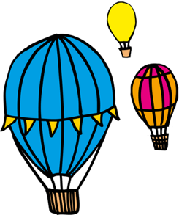
Graphic scores are a tool whereby composers can write music but without using any of the typical musical notations. In fact, many graphic scores look like pieces of art work! Some graphic scores are structured and others are much more free. The beauty of graphic scores like these is that they can be interpreted in lots of different ways. In this lesson, you will create a class graphic score and read it together using vocal sounds. Then the children will have the opportunity to create their own scores in groups or in pairs. There are no right or wrong symbols/pictures, however, most composers will intend for every curl, flick and shape to have some kind of musical meaning. For example, if you were to draw a large star followed by a tiny one, you could infer that the larger star would be played louder than the smaller one. Or if a circle was drawn at the top of a page and another one at the bottom, this could infer that the circle at the top is at a higher pitch than the one below. You can have fun creating your own scores. Using a paint app is a fun way to introduce textures and colour into your scores. Even colour choices can have a musical meaning if you want them to. You can use onomatopoeic words for added vocal effect, e.g. bang, whoosh, ping, pop, weeeee!

Begin by using the graphic score of a balloon as a model and then create your own ‘balloon’ with the class. The gaps between the dots are deliberate so that there is silence. Don’t be afraid of adding silent sections to your piece. Have a go at demonstrating vocal sounds using your voice to model to the children.

Once the class have added sounds to the group score, set pairs or small groups the task of discussing what other sounds they might like to create symbols for. Given the pupils the opportunity to explore the timbres available using a selection of class percussion instruments. Pupils should consider a balloon flight and what sounds they might hear. (Do the symbols represent the sound of the hot air balloon rising from the ground or perhaps the effects of the weather on its journey through the air or even the landmarks you pass). What symbols best express your chosen sounds?

Plenary:
Return to the song ‘Up, Up, Up’ (Lesson 1). Remind children what they said could be improved next time in terms of their performance of the song. Sing the chorus and go on to learn a verse.
Keywords / vocabulary: Graphic score, structure, notes, pictures, mood, feeling, pitch, melody, dynamic, texture, duration - rhythm, timbre, silence, echo.
Extension opportunities: The children could revisit the balloon scores and consider how they could indicate how to represent pitch – high/low and dynamics – loud/soft by adding either colour or traditional symbols such as f (loud), p (soft) to the score.
Self-assessment opportunities: (I can...)
- I can create symbols to represent sounds and notate them as a graphic score.
- I can choose sounds/timbres to represent ideas.
- I can echo simple rhythms.
- I can internalise a pulse in a song.
- I can maintain my part in a group performance.
Resources: Balloon Graphic score.
Opportunities for sharing work: Record performances and photograph/print examples of work to display.

Music Assessment: Reception / KS1 Air Lesson 3

You only need to note the names of children who are working towards or well above the criteria for the lesson. It will be assumed that the majority of the class will achieve the objectives and you don’t need to record this. Use the space below for any specific notes on achievement or evaluation of class progress.
Names of any children who do not meet the learning objectives for this lesson | ‘I can’ assessment criteria | Names of any children who exceed the learning objectives for this lesson.
I can create symbols to represent sounds and notate them as a graphic score.
I can choose sounds/timbres to represent ideas.
I can echo simple rhythms
I can internalise a pulse in a song
I can maintain my part in a group performance.
Notes:

