Music Lesson Plan topic – Pitch

Lesson 6 of 6 Focus: Year R/1/2
Early Learning Goals :
- To sing and play intervals as part of a song.
- To play a melodic ostinato on the strong beats of the bar.
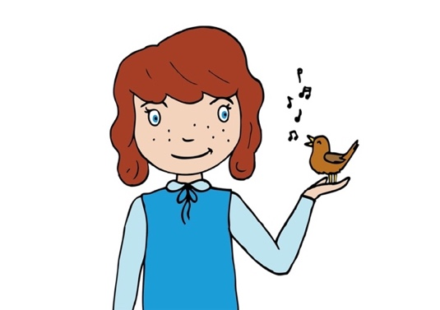
Inter-related music dimensions covered: Pitch, duration (pulse, rhythm).

Starter activity:
- Draw attention to the way children are sitting/standing. Tell them to stand/sit like a frozen fish finger (stiff and tense) and then like a floppy fish finger that has been out of the freezer for hours and is a chilled-out fish finger now.
- Now ask the children to blow up a bubble. They should take a big breath in and imagine their lungs are like a tank that they are filling up with air. They should then blow out gradually using their hands as the imaginary size of the bubble. As they blow into the “bubble”, their hands form a bigger bubble. The bubble gets bigger and bigger until the children run out of air and the bubble pops! When their bubble pops, they should clap their hands to reflect that they have run out of air.
- Big face, small face: Using these two instructions, stretch and scrunch your face.

- Return to Dr Knickerbocker Singup as last week.

Main focus:
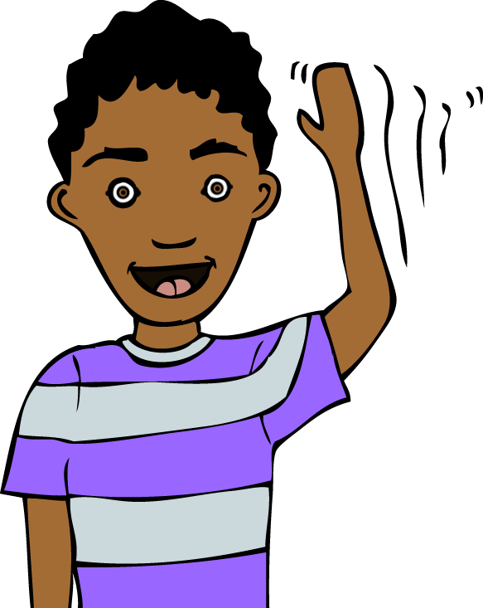
Tell the children that today we will be learning the second part of the song ‘The River’, and also adding some instruments to the performance. Do they know what it is called when instruments play along with a song? The instruments provide an accompaniment. We will be accompanying the song.

Using call and response as on the audio file to teach the next part of the song, from the ‘Mother Earth carry me’. On which word is the highest pitch? (“Mo-ther”). Trace the pitch of the line ‘Mother Earth carry me’.What happens to the pitch? (It goes down by step).

In unison (all together), sing from the beginning of the song as far as bar 10 “down to the sea”. Practise this a number of times.
Divide the class into two groups and choose a ‘Captain conductor’ for each. One group will sing the first part of the song ‘The river is flowing’ and then voice 2 will start in bar 14.

Listen to the harmony part – ‘flowing growing’ bar 23. (see audio file). The children should use their hands to reflect the direction of the pitch (head, shoulders, knees and toes) on flow-ing, grow-ing. Here the melody moves in leaps not steps as earlier. Use the recording to learn this part.
Sing the glockenspiel part (audio file). Do the children notice that the rhythm for this is the same as the harmony part at bar 23. One or two children can play this repeated melodic ostinato along with the recording (use a glockenspiel with all the notes removed except E and B above). If there are enough tuned percussion instruments then half the class can play whilst the other half sing the song (then swap).

Plenary:
Choose a small group of strong players to play the tuned percussion. Divide the rest of the class in half and try performing the two vocal parts with the glockenspiel, using the backing track to aid confidence.

Opportunities for mastery: Try performing with the performance track rather than the rehearsal track. A small group of children could play a rhythmic ostinato on the drums. - “Clap, quick, quick, quick, quick, clap” (river is flowing) whilst the others are singing. When would this work in the song? It could be played all the way through or just in one section.
Keywords / vocabulary: Conductor, melodic / rhythmic ostinato, accompaniment, duration (rhythm, pulse, strong beat), interval (step, leap), unison, harmony, pitch, melody.
Self-assessment opportunities:
- I can sing and play intervals as part of a song.
- I can play an ostinato on the strong beats of the bar.
Resources:
- The River is Flowing music and mp3.
- Glockenspiel with only E and B bars left.
- Graphic score of “the river is flowing” from the last lesson.
- Singup.
- Drums.

Opportunities for sharing work e.g. by recording, notation: Recording of performance.

Music Assessment: Year R/1/2 Pitch/Chronology Lesson 6
You only need to note the names of children who are working towards or well above the criteria for the lesson. It will be assumed the majority of the class will achieve the objectives and you don’t need to record this. Use the space below for any specific notes on achievement or evaluation of class progress.

Names of any children who do not meet the learning objectives for this lesson | ‘I can’ assessment criteria | Names of any children who exceed the learning objectives for this lesson.
- I can sing and play intervals as part of a song

- I can play an ostinato on the strong beats of the bar
Notes:

