Music Lesson Plan topic – Pitch

Lesson 4 of 6 Focus: R
Early Learning Goal:
- To recognise that music is notated to show both pitch and duration.
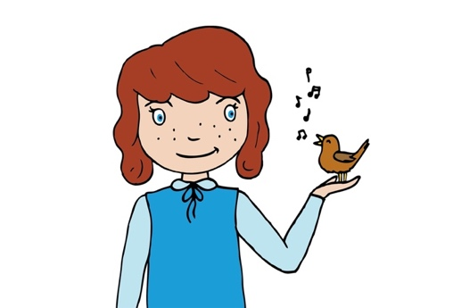
Inter-related music dimensions covered: Pitch, duration, timbre.
Starter activities:
Children focus on three different points in the room as before, but this time the teacher refers to the clock as 1, whiteboard as 2 and the window as 3. Only the children’s eyes and their head must move, nothing else. You can say 1, 2, 3, ME! Or mix the numbers up for an added challenge.

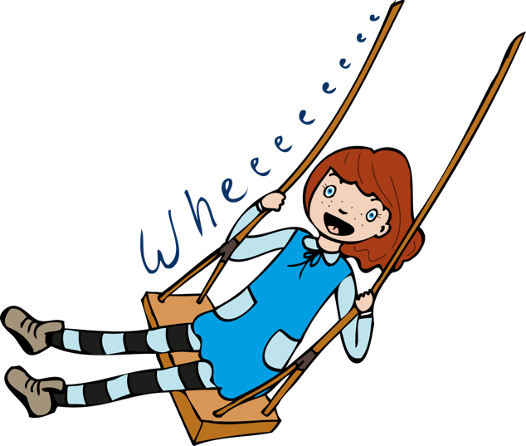
Magic Ball: the children follow a ball with their voice. Whatever the ball does, their voices must mirror. When the ball goes really high, what happens to their voices ? (they get very high) – you could get the children to say “wheeee!” along with the ball height). Throw the ball up at various heights. Make sure you tell the children that they must be focusing their eyes on the ball the entire time or they won’t know what to do with their voice. End by dropping the ball – how is that reflected in their voices?

‘Hi-Lo Chicalo’: (see video with hand clapping activity). This very simple song reinforces kinaesthetically and aurally for the children the concept of high and low notes. Sing or play the song for them first and then teach it very slowly line by line in a call and response fashion e.g.: “Hi Low Chicolo” (they repeat), “Chicolo Chicolo” (they repeat) etc. Use paired clapping as in the extract to indicate high/low notes.

Main focus:
Listen to ‘Abeeyo’, it is a welcome song orignially sung by indigenous Australians. It is a call and response song. Learn the responses using the clip. Why do you think it is a welcome song? (Because one leader is “calling” to the others and they are answering, also, it is loud and friendly). What do you notice about notes at the beginning (they are long, stretched, lazy notes, like saying “heeeeeeeey there!”) What about the other notes (they are short, fast, busy notes). What do you think they might be saying? (hello, how are you?) Does it sound like it’s a happy song or a sad song? (happy). Does it start high or low? (high). Does it mostly move by steps or leap? (leaps).

Divide the children into two groups. Tell them they will be singing this song to each other as if they are calling and answering from one mountain to another. You could get them to cup their hands around their mouths to make it fun. One group is the “caller” and the other is the “responder”. Ask the children to vary the dynamic e.g. call: loud forte, response: soft piano, call: soft piano, response: loud forte.
Ask the children to sing the call (abeeee yo) and “body pitch” the sounds. (stand tall and then crouch a little)

Show the chidren on a flipchart how the notes go from high (and long) to middle (and short). For example: A beeee --- yo! Could be represented as This represents pitch and duration.

Plenary:
How many pitches does it use? (two). Sing it with letter names and then some children use tuned percussion to play this ostinato (repeating pattern) whilst others sing the call and response.
Opportunities for mastery: Recall Peter and the Wolf instruments (see resources – Sparklebox page of instruments with corresponding animals next to them). Which instruments would be the most appropriate for the call in Abeeyo? Why? The Horn, this was originally used for sounding calls when hunting or in battle.
Keywords / vocabulary:
Pitch (high, middle, low) step, leap, soft, piano, loud, forte, call, response, repeat.
Self-assessment opportunities:
- I can recognise that music is notated to show both pitch and duration.
- I can lead a call and sing a response.
Resources:
- Ball.
- Clips of songs.
- Tuned percussion.
- “Hi Lo Chicolo” clapping game instructions Singing Games and Rhymes for middle years.
Opportunities for sharing work e.g. by recording, notation: Video of children singing “Abeeyo” to one another whilst “body pitching” the notes.

Music Assessment: Year Reception Pitch Lesson 4
You only need to note the names of children who are working towards or well above the criteria for the lesson. It will be assumed the majority of the class will achieve the objectives and you don’t need to record this. Use the space below for any specific notes on achievement or evaluation of class progress.

Names of any children who do not meet the learning objectives for this lesson | ‘I can’ assessment criteria | Names of any children who exceed the learning objectives for this lesson.
- I can recognise that music is notated to show both pitch and duration.

- I can lead a call and sing a response.
Notes:

