Music Lesson Plan topic – Pitch

Lesson 3 of 6 Focus: Year R
Early Learning Goals:
- To discriminate between changes in pitch, recognising high, middle and low sounds.
- To use the voice to copy a simple melodic pattern.
- To play a simple melodic pattern on an instrument.
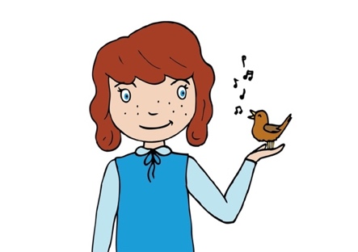
Inter-related music dimensions covered: Pitch, duration (pulse/rhythm).

Starter activity:
Warm up with face movements - yawning/making a silent scream/chewing movements.
Breathing activity: Take a deep breath, then start on a low note and make your voice fly as if you are an aeroplane climbing into the sky, singing up to a high note as breath runs out. Repeat a couple of times.
Sing ‘Row, row, row the boat’ and then perform as a round in 2 parts. The first group begins and the second group start a line after first group (after the word stream). Appoint a strong singer to lead each group. (see resource: audio file). This type of follow on song is called a round or canon.
Use focus points around the room for the children to turn their head on instruction e.g. “look at the clock, look at the door LOOK AT ME”. Swap between directions reminding the children to move their heads and nothing else!

Main focus:
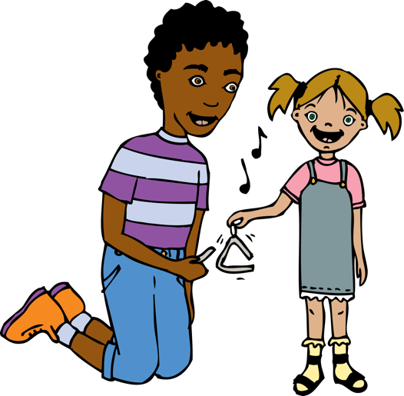
- Introduce ‘Hot Cross Buns’ and sing. (audio file). Discuss how the children might change the words to high/middle/low/down the ladder/up the ladder to reflect the pitch. Children work in pairs to place the cards in order. Use word cards (see resource). Now sing the new words as below to highlight where there are leaps/steps in the song. “high, low, middle, high, low, middle, down the ladder, up the ladder high, low, middle”. Add in movements for the children to do as they sing- stretch/crouch/stand x2, sink down slowly, rise again and stretch/crouch/stand.
- Now also add in some tuned percussion (xylophones, glockenspiel or chime bars) for the children to practise playing ‘high, low middle’ each time. They will need top D, low D and G, between the two. Can they work out which note is the high, the low and the middle?
- Sing with these accompanying instruments (another pupil could play the ‘down the ladder, up the ladder’ section (they would need going up G,A,B,C,D).
- What would this look like if it was written down? See resource. Children point to the notes as they sing/ Do the children notice the repeated pattern? (high low middle), and the scales (down the ladder/up the ladder).

Plenary:
Do you remember the characters in the story of Peter and the Wolf? Which character was represented by an instrument playing high sounds? Can you remember the name of the instruments used (flute/strings, bird/Peter)? Listen to this extract from the story where the cat is stalking the bird. The bird is too busy arguing with the duck to notice. (www.youtube.com/watch?v=9ueGfjBKbiE 7:20-11:06) Which character’s melody is the lowest, the bird, the cat or grandfather? (grandfather). Which instrument plays the melody to represent Peter? (violin/strings).

Opportunities for mastery: Ask the children compose their own melody/tune with high/low and middle notes? Can they notate it?
Keywords / vocabulary: Pitch (high/middle/low) , scale, step/leap, up/down, duration (pulse/steady beat, rhythm) melody, notation, round, canon.

Self-assessment opportunities:
- I can identify and sort pitch cards to represent a melodic shape.
- I can use my voice to pitch the steps and leaps of a melody.
- I can find and play a simple melodic pattern on an instrument.
Resources: Tuned percussion instruments- xylophones/ glockenspiels/ chime bars
Recordings of ‘Row, Row, row the boat’, ‘Hot Cross Buns’
Pitch notation cards powerpoint
Pictures of instruments ( free download from Sparklebox) http://www.sparklebox.co.uk/previews/9951-9975/sb9967-peter-and-wolf-instrument-posters.html#.Wbu_GbpFzIU
Clip from Peter and the Wolf. www.youtube.com/watch?v=9ueGfjBKbiE 7:20-11:06)

Opportunities for sharing work e.g. by recording, notation:
Video the children playing instruments to accompanying their singing of ‘Hot cross buns’
Video of the performance of the round ‘Row, row, row the boat’.

Music Assessment: Year Reception Pitch Lesson 3
You only need to note the names of children who are working towards or well above the criteria for the lesson. It will be assumed the majority of the class will achieve the objectives and you don’t need to record this. Use the space below for any specific notes on achievement or evaluation of class progress.

Names of any children who do not meet the learning objectives for this lesson | ‘I can’ assessment criteria | Names of any children who exceed the learning objectives for this lesson.
- I can identify and sort pitch cards to represent a melodic shape.

- I can use my voice to pitch the steps and leaps of a melody.

- I can find and play a simple melodic pattern on an instrument
Notes:

